CISC SIMULATOR

Manual

V 4.1

**Group 8**

Md Shahjalal

Tianyou Bao

Xuzheng Lu

Contents

1 Introduction 1

1.1 Debugging Panel 1

1.1.1 Register Indicators Area 1

1.1.2 Memory Area 2

1.1.3 Controller Area 2

1.2 Operation Panel (Console) 3

1.3 Themes 4

2 Design Notes 6

2.1 Packages 6

2.2 Interaction Logic 7

3 Basic Operations 9

3.1 Writing Values to Registers 9

3.2 Writing Values to Memory 9

3.2.1 Using Memory Address Register and Memory Buffer Register 9

3.2.2 Modifying the Memory Area 10

3.3 Inputting from the Outside 10

3.3.1 Inputting from Keyboard 11

3.3.2 Inputting a Program 11

3.3.3 Inputting from Card Reader 12

3.3.4 Inputting from Text File 12

3.3.5 Overwriting the Memory from Outside 12

3.4 Executing Instructions 13

3.4.1 Executing Instructions Step-by-Step 13

3.4.2 Executing Instructions Automatically 14

4 Executing Programs 16

4.1 Executing Program 1 16

4.1.1 Program 1 Description 16

4.1.2 Program 1 Files 16

4.1.3 Running Program 1 16

4.2 Executing Program 2 18

4.2.1 Program 2 Description 18

4.2.2 Program 2 Files 18

4.2.3 Running Program 2 19

4.3 Executing a Custom Program Using IPL 21

4.3.1 Using Operation Panel (Console) 21

4.3.2 Using Debugging Panel 22

5 Instructions Reference 24

5.1 Load/Store Instructions 24

5.1.1 (01) LDR 24

5.1.2 (02) STR 24

5.1.3 (03) LDA 25

5.1.4 (41) LDX 25

5.1.5 (42) STX 25

5.2 Arithmetic and Logical Instructions 25

5.2.1 (04) AMR 26

5.2.2 (05) SMR 26

5.2.3 (06) AIR 27

5.2.4 (07) SIR 27

5.2.5 (20) MLT 27

5.2.6 (21) DVD 28

5.2.7 (22) TRR 28

5.2.8 (23) AND 28

5.2.9 (24) ORR 28

5.2.10 (25) NOT 29

5.3 Transfer Instructions 29

5.3.1 (10) JZ 29

5.3.2 (11) JNE 30

5.3.3 (12) JCC 30

5.3.4 (13) JMA 30

5.3.5 (14) JSR 30

5.3.6 (15) RFS 31

5.3.7 (16) SOB 31

5.3.8 (17) JGE 31

5.4 Shift/Rotate Instructions 32

5.4.1 (31) SRC 32

5.4.2 (32) RRC 32

5.5 Floating Point and Vector Instructions 33

5.5.1 (33) FADD 33

5.5.2 (34) FSUB 33

5.5.3 (35) VADD 34

5.5.4 (36) VSUB 34

5.5.5 (37) CNVRT 34

5.5.6 (50) LDFR 35

4.5.7 (51) STFR 35

5.6 I/O Instructions 35

5.6.1 (61) IN 36

5.6.2 (62) OUT 36

5.6.3 (63) CHK 36

5.7 Other Instructions 37

5.7.1 (00) HALT 37

5.7.2 (30) TRAP 37

# 1 Introduction

This simulator is a simulation of a Complex Instruction Set Computer (CISC). Three panels are designed for the simulator, and two themes are supported.

## 1.1 Debugging Panel

**Debugging Panel** displays all the information about the Registers, Indicators, and Memory in the computer and can be written manually.

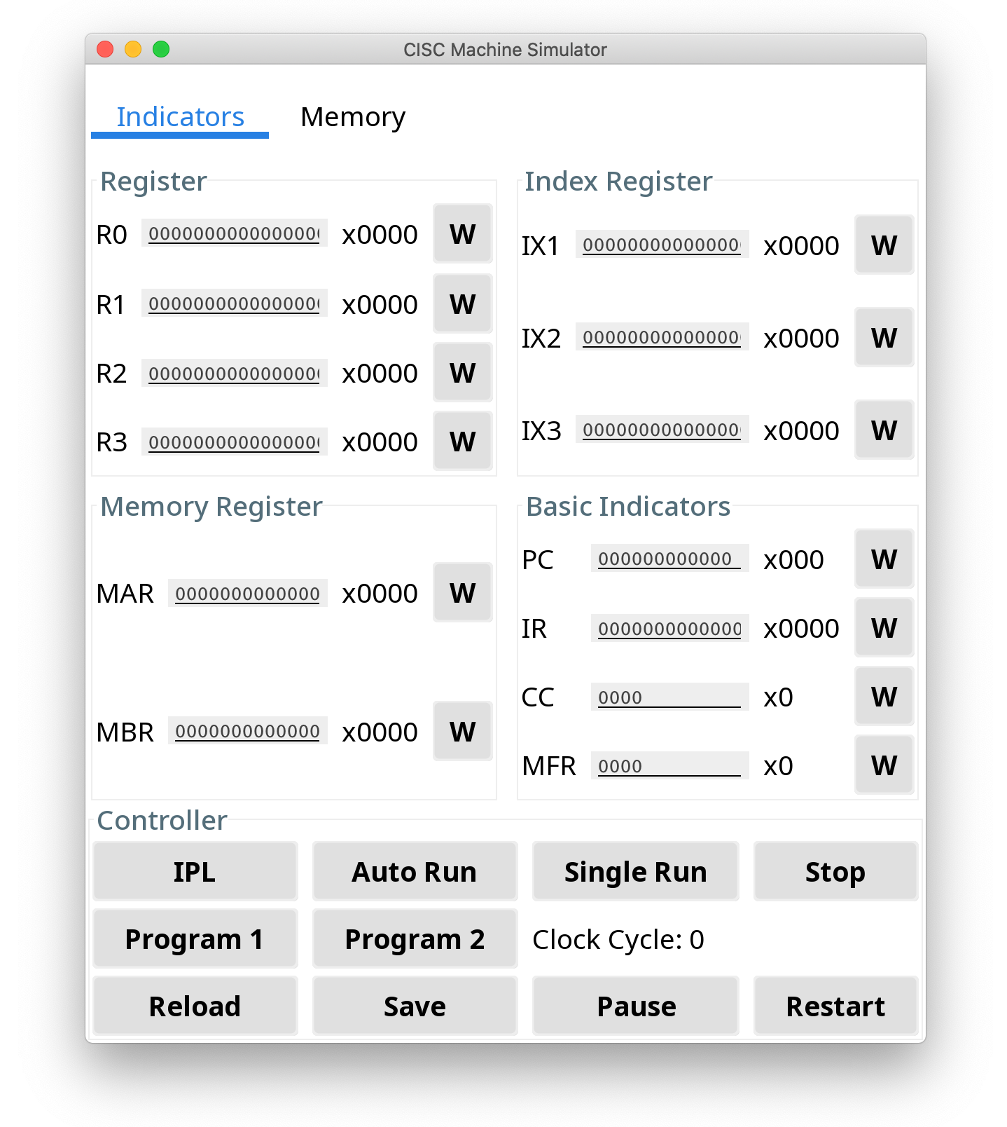

The panel is divided into three parts：

### 1.1.1 Register Indicators Area

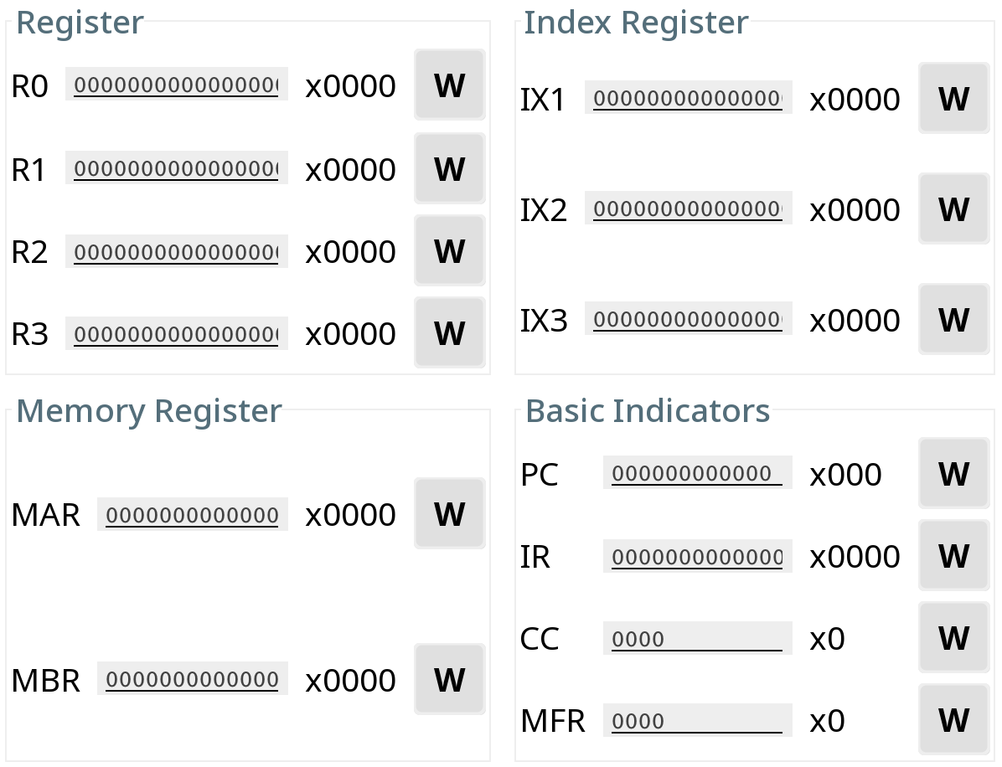

The Register Indicators display the values of all kinds of registers.

* Click the ‘W’ button to manually modify the value of a register.
* Hexadecimal values are shown on the right.

|  |  |  |  |
| --- | --- | --- | --- |
| **Type** | **Size(bits)** | **Number** | **Description** |
| R0...R3 | 16 | 4 | General-Purpose Register |
| IX1...IX3 | 16 | 3 | Index Register |
| MAR | 16 | 1 | Memory Address Register |
| MBR | 16 | 1 | Memory Buffer Register |
| PC | 12 | 1 | Program Counter |
| IR | 16 | 1 | Instruction Register |
| CC | 4 | 1 | Condition Code |
| MFR | 4 | 1 | Machine Fault Register |

### 1.1.2 Memory Area

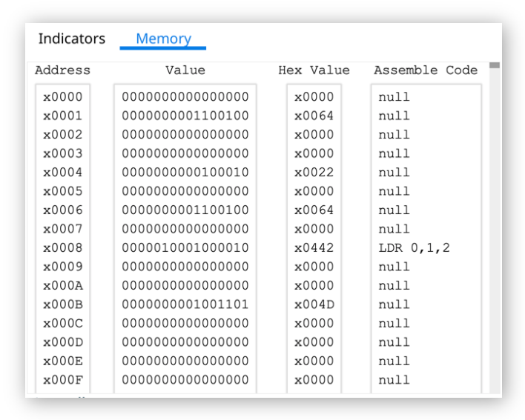

The Memory Area shows the address, the value, the Hexadecimal value, and the Assemble Code of each line on memory.

* The memory address pointed by the Program Counter will be highlighted.
* Double click to manually modify the binary value of a memory row.

### 1.1.3 Controller Area

The Controller Area integrates all function buttons and the instruction input box.

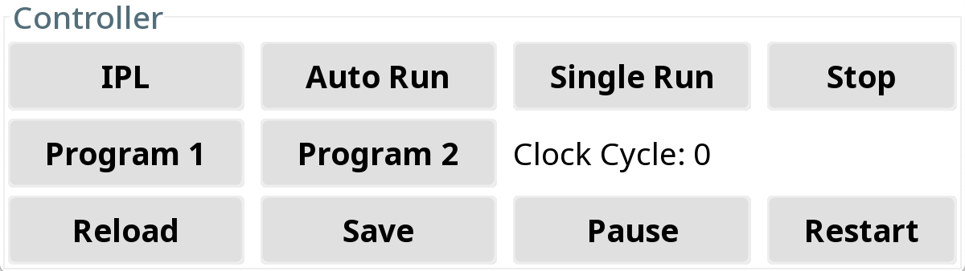

Functions of the buttons in Controller Area:

|  |  |
| --- | --- |
| **Button** | **Function** |
| IPL | Pre-load a program from I/O |
| Auto Run | Run the instructions until TRAP or HALT |
| Single Run | Run one instruction |
| Stop | Stop the workload on the machine |
| Program 1 | Run Program 1 |
| Program 2 | Run Program 2 |
| Clock Cycle | Shows the clock cycle during program |
| Reload | Reload the data from memory.txt to memory |
| Save | Save the data in memory to memory.txt |
| Pause | Pause the workload on the machine |
| Restart | Restart the machine |

## 1.2 Operation Panel (Console)

**Operation Panel** is a console used for system operation through the command line.

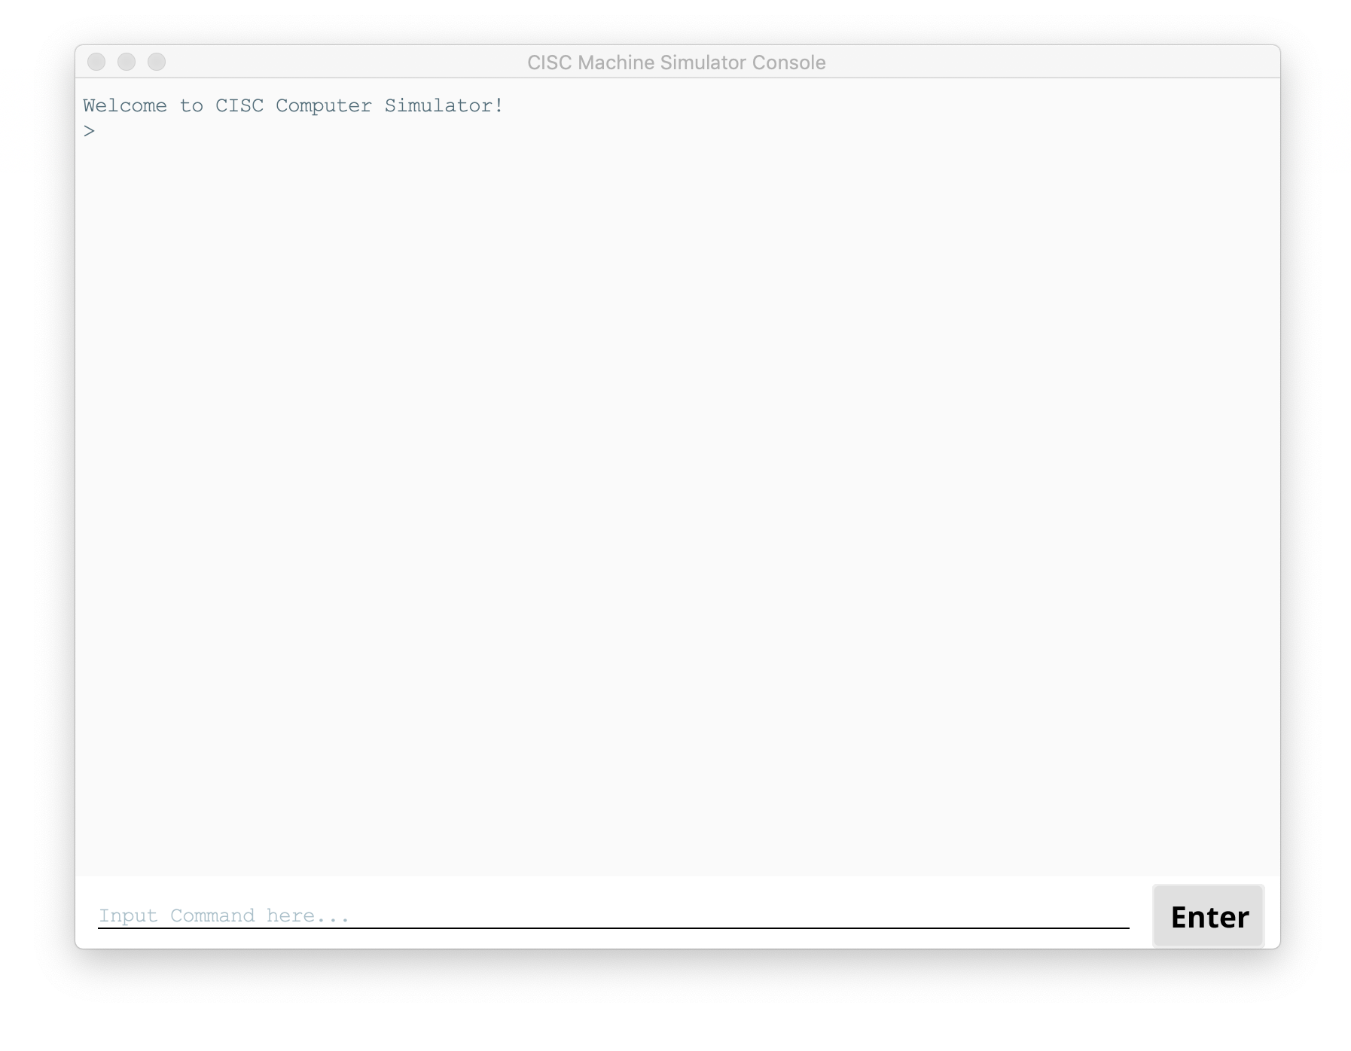

Commands supported:

|  |  |
| --- | --- |
| **Command** | **Description** |
| autorun | Run the instructions until TRAP or HALT (Same as ‘auto run’ and ‘run’) |
| auto run | Run the instructions Until TRAP or HALT (Same as ‘autorun’ and ‘run’) |
| clean | Clean the console (same as ‘cls’) |
| cls | Clean the console (same as ‘clean’) |
| exit | Shutdown the machine (same as ‘quit’ and ‘power off’) |
| ipl | Load the program from I/O |
| pause | Pause the workload on the machine (not finished) |
| power off | Shutdown the machine (same as ‘exit’ and ‘quit’) |
| Program1 | Run Program 1 (same as ‘Program 1’) |
| Program 1 | Run Program 1 (same as ‘Program1’) |
| Program2 | Run Program 1 (same as ‘Program 2’) |
| Program 2 | Run Program 1 (same as ‘Program2’) |
| quit | Shutdown the machine (same as ‘exit’ and ‘power off’) |
| reload | Reload the data from memory.txt to memory |
| reset | Restart the machine (Same as ‘restart’) |
| restart | Restart the machine (Same as ‘reset’) |
| run | Run the instructions until TRAP or HALT (same as ‘autorun’ and ‘auto run’) |
| save | Save the data in memory to memory.txt |
| singlerun | Run one instruction (Same as ‘single run’) |
| single run | Run one instruction (Same as ‘singlerun’) |
| status | Show the status of the machine |
| stop | Stop the workload on the machine |
| switch theme | Switch the theme of UI  Format: switch theme {$THEME_NAME}  Now support ‘Material Design Ocean’ (or ‘MaterialDesignOcean’) and ‘Material Design Lighter’ (or ‘MaterialDesignLighter’) |
| /help | Show the command list |

## 1.3 Themes

Two themes, Material Design Ocean and Material Design Lighter, are supported now.

To change the theme, input ‘switch theme {$THEME_NAME}’ in **Operation Panel**.

**Material Design Lighter Theme (default)**

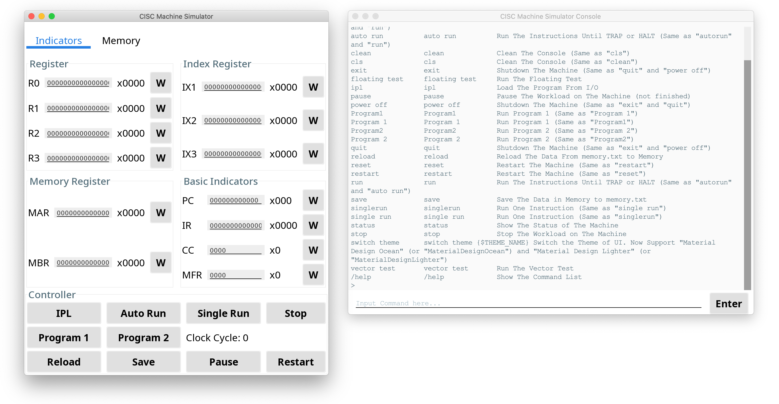

**Material Design Ocean Theme**

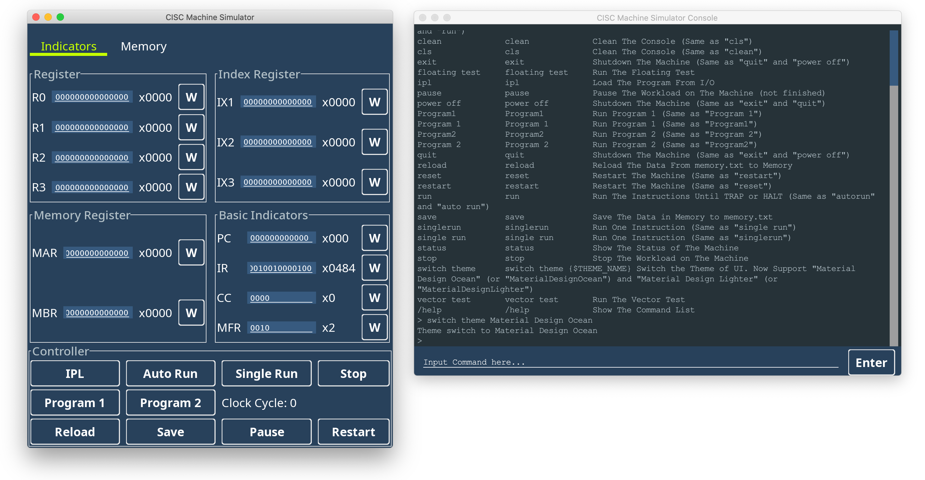

# 2 Design Notes

## 2.1 Packages

Source code is divided into following packages:

* common
* device
* instruction
* memory
* panel
* program
* register
* theme
* util

All the operations initialize by Main class. That class initializes class, which initializes CISCComputerClass. All the register, memory and essential variables get ready for running.

**1) Common Package**

This package contains the main CiscComputer class which contains all the register, memory, devices, clock cycle count.

Class display is used for displaying states of all the elements of CiscComputer.

Initializer Class used for initializing all the elements of CiscComputer.

**2) Device Package**

Device package contains CardReader, ConsoleKeyboard, ConsolePrinter.

All of these extended from abstract class Device and has unique DeviceType, which is enum.

**3) Instruction Package**

This package contains class for all the operations. ArithmeticLogicalInstructionProcessor,

FloatingPointInstructionProcessor, InputOutputInstructionProcessor, LoadStoreInstructionProcessor, MiscellaneousInstructionProcessor, TransferInstructionProcessor implements interface Instruction to be called and perform any instruction. All of this class has unique enum InstructionType.

This package also contains Address decoder to decode the address for an instruction.

**4) Memory Package**

This package contains Address class, which is a combination of tag and offset for caching. The cache contains, CacheLine and each CacheLine contain 8 Words, that means contains 8 location of main memory. Memory class is the main memory which as a 16-bit boolean value.

**5) Panel Package**

This package contains classes for UI. Controller, DebugPanel and OptionPanel.

**6) Register Package**

This package contains all the registers which extend from abstract Register. All the register has a unique RegisterType.

**7) Theme Package**

Contains class for UI looks.

**8) Util Package**

Common functions used all over the system kept here.

## 2.2 Interaction Logic

The interaction logic is shown as the image on the next page.

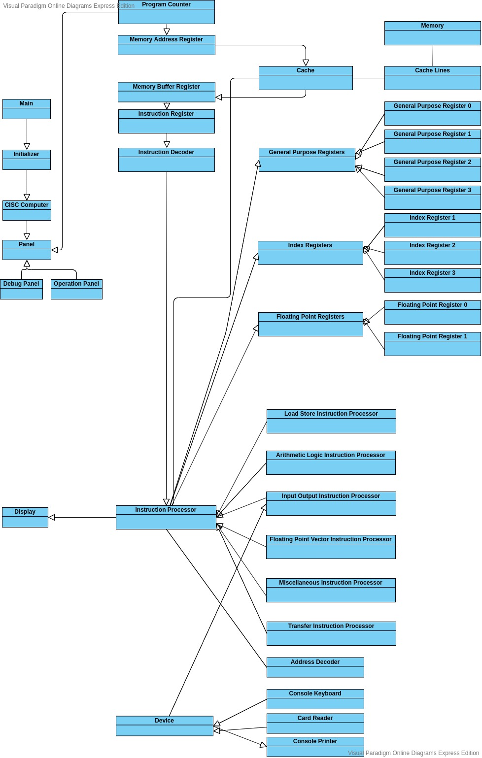

# 3 Basic Operations

## 3.1 Writing Values to Registers

Following the steps below to write a value to a register.

**Step 1**: Input a value into the box.



**Step 2**: Click the ‘W’ button at right to write the value to the register.



**Step 3**: Done! The value will be written to the Register.

**Error handling:**

- Input too long: Remove the excess bits from the left

- Input too short: Add zeros from the left

- Input is not binary: Pop up an Error window

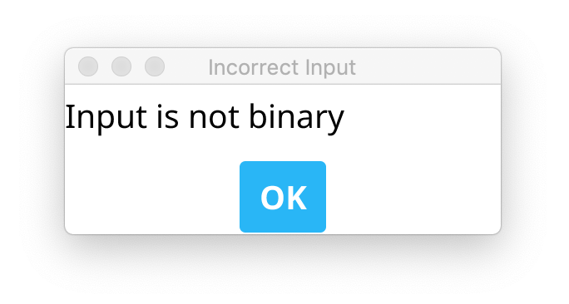

## 3.2 Writing Values to Memory

Two methods are acceptable to write a value to the Memory.

### 3.2.1 Using Memory Address Register and Memory Buffer Register

**Step 1**: Input a value into the MAR box.



**Step 2**: Click the ‘W’ button of MAR.



**Step 3**: Input a value into the MBR box.



**Step 4**: Click the ‘W’ button of MBR.



**Step 5**: Done! The value of MAR will be written to the Memory, and the MAR will automatically change to the next address.

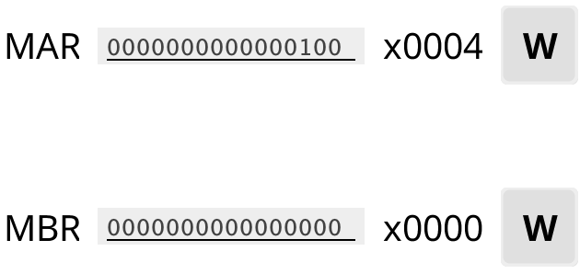

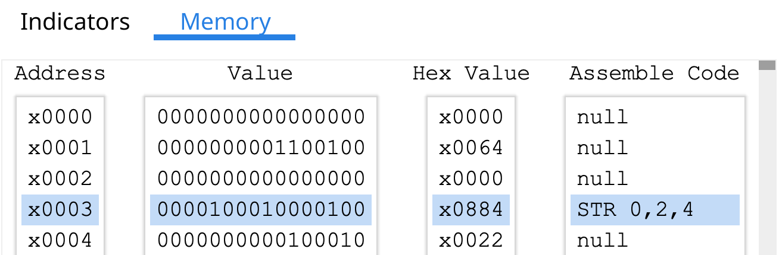

### 3.2.2 Modifying the Memory Area

**Step 1**: Double click the memory row that needs to modify.

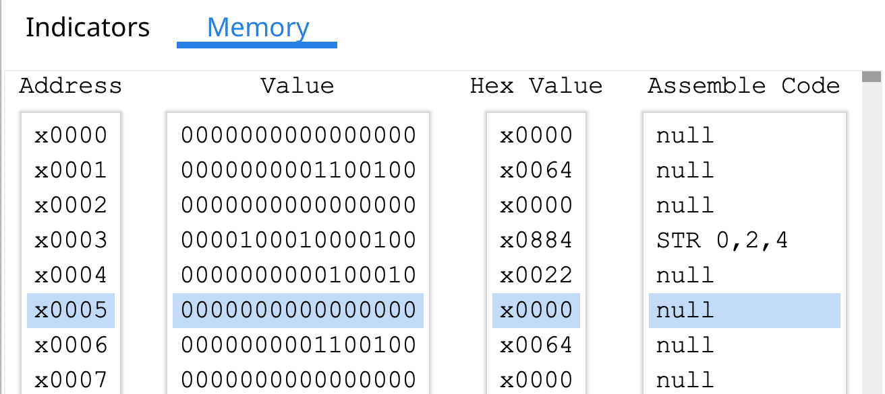

**Step 2**: A window as the following will pop up. Input the value to be written to the memory.

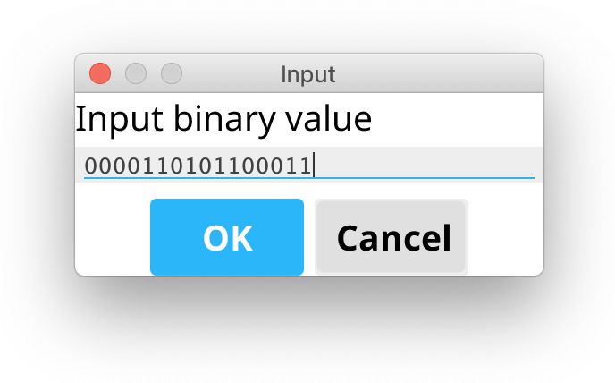

**Step 3**: Click the ‘OK’ button, and then the value will be written to the Memory.

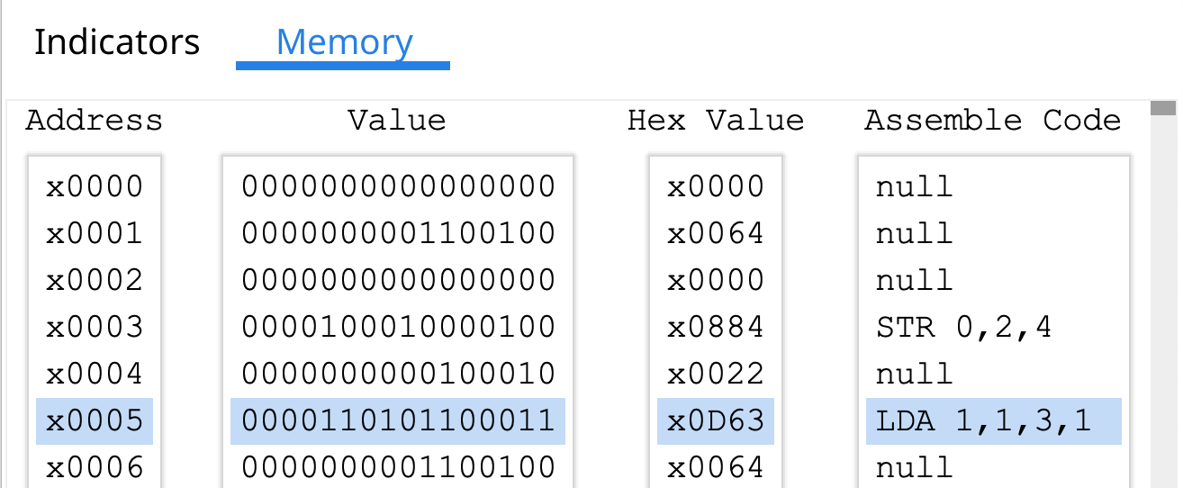

## 3.3 Inputting from the Outside

There are several ways for inputting from the Outside, form **Keyboard** or **IPL files**.

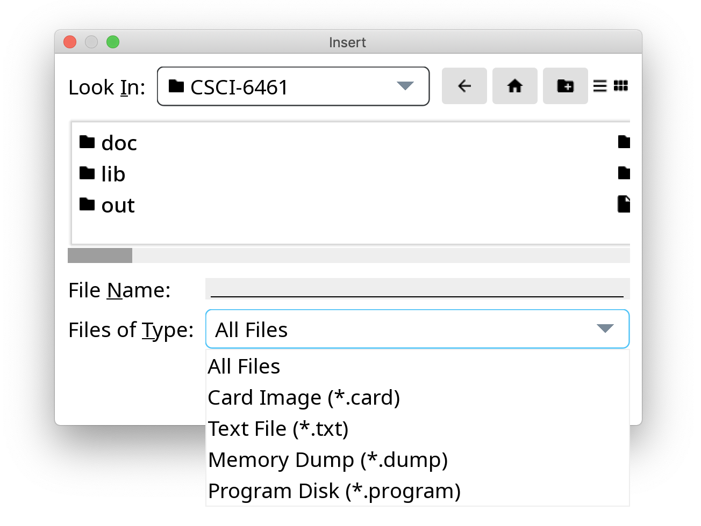

### 3.3.1 Inputting from Keyboard

Input words in the **Operation Panel (Console)** when the program asks for some keyboard inputs and then click the ‘Enter’ button.

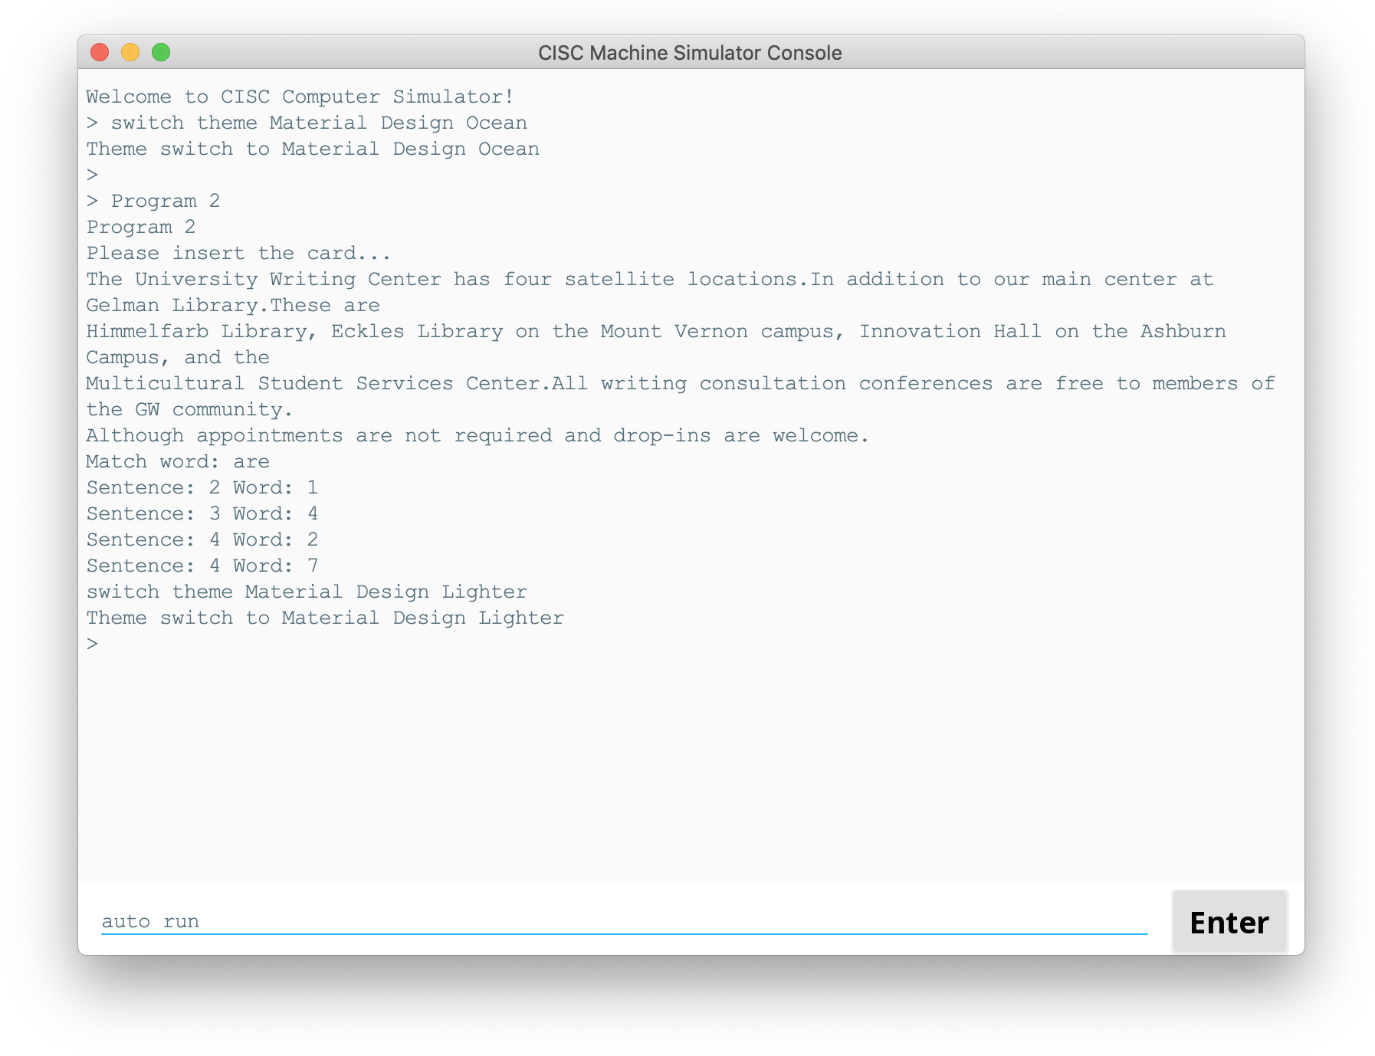

### 3.3.2 Inputting a Program

Input ‘ipl’ command to the **Operation Panel (Console)** or click the ‘IPL’ button in the **Debugging Panel**. Choose a ‘.program’ file to be inserted into the machine. Then, the program will be loaded to Memory.

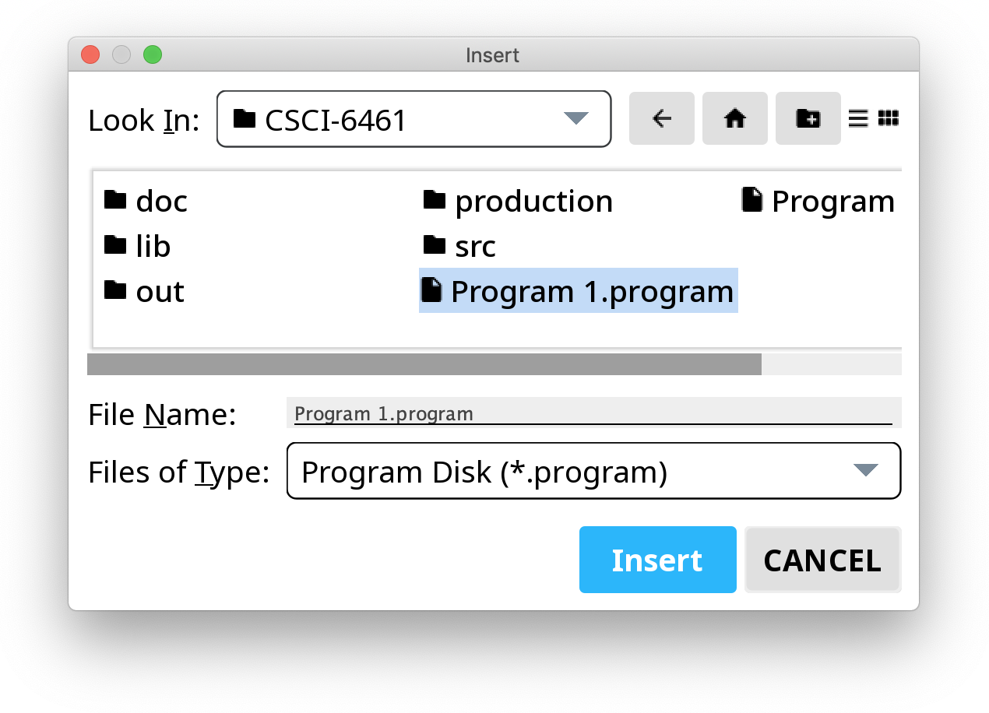

### 3.3.3 Inputting from Card Reader

Input ‘ipl’ command to the **Operation Panel (Console)** or click the ‘IPL’ button in the **Debugging Panel**. Choose a ‘.card’ file to be inserted into the machine. Then, the card file will be loaded to Memory, using Card Reader as input device.

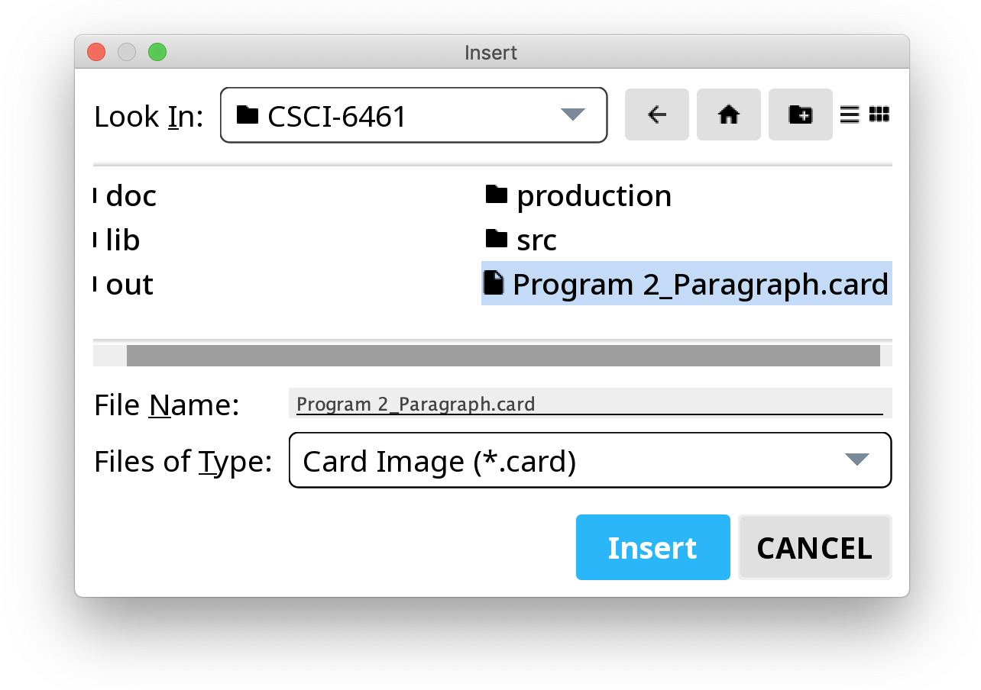

### 3.3.4 Inputting from Text File

Input ‘ipl’ command to the **Operation Panel (Console)** or click the ‘IPL’ button in the **Debugging Panel**. Choose a ‘.txt’ file to be inserted into the machine. Then, the text file will be loaded to Memory.

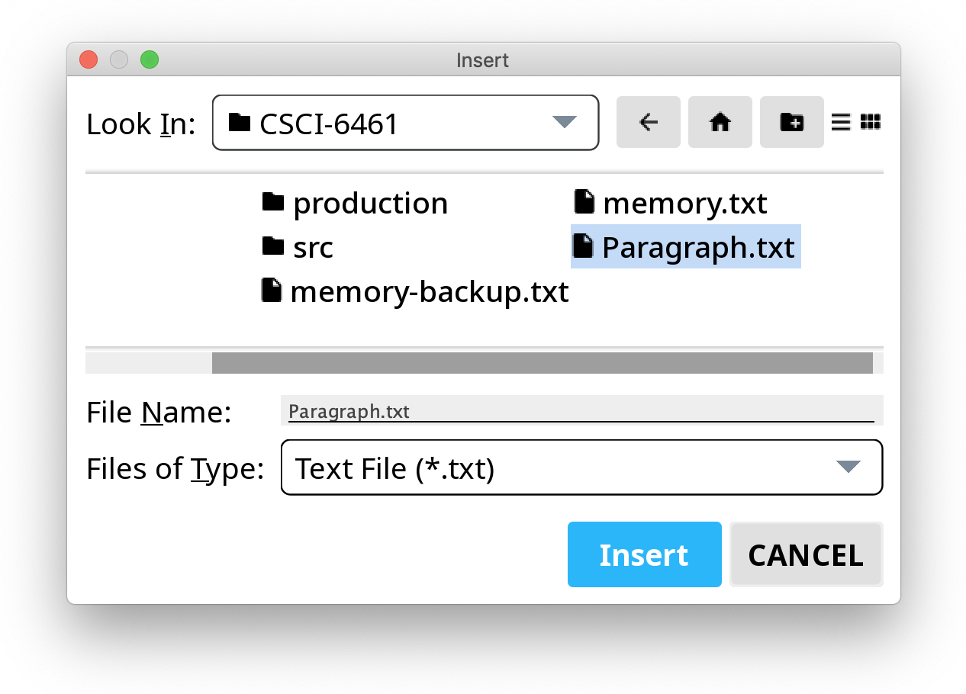

### 3.3.5 Overwriting the Memory from Outside

Input ‘ipl’ command to the **Operation Panel (Console)** or click the ‘IPL’ button in the **Debugging Panel**. Choose a ‘.dump’ file to be inserted into the machine. Then, the Memory will be overwritten by the memory file.

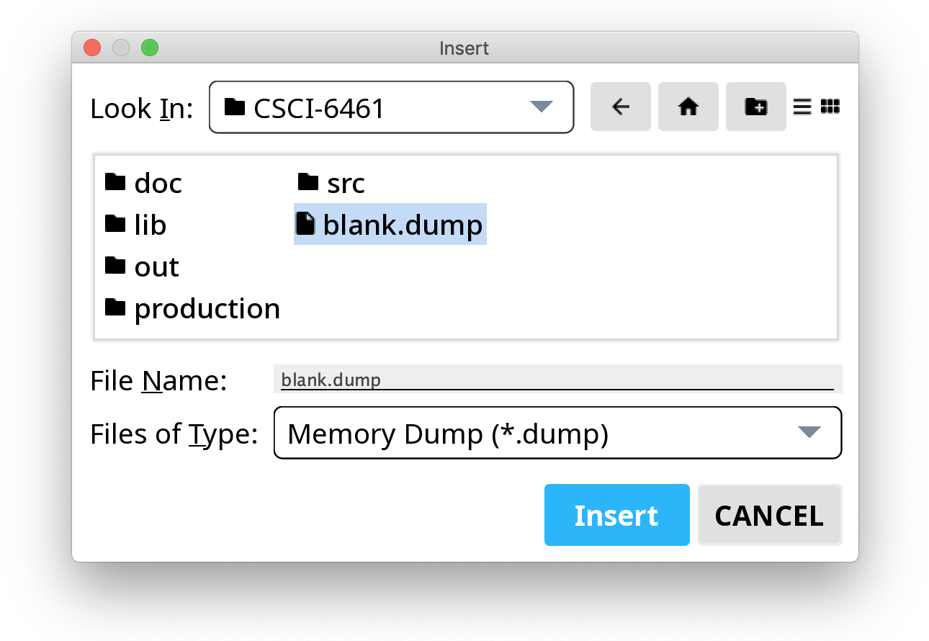

## 3.4 Executing Instructions

Instruction can be executed step-by-step or automatically.

### 3.4.1 Executing Instructions Step-by-Step

**Step 1**: Store an instruction to the Memory.

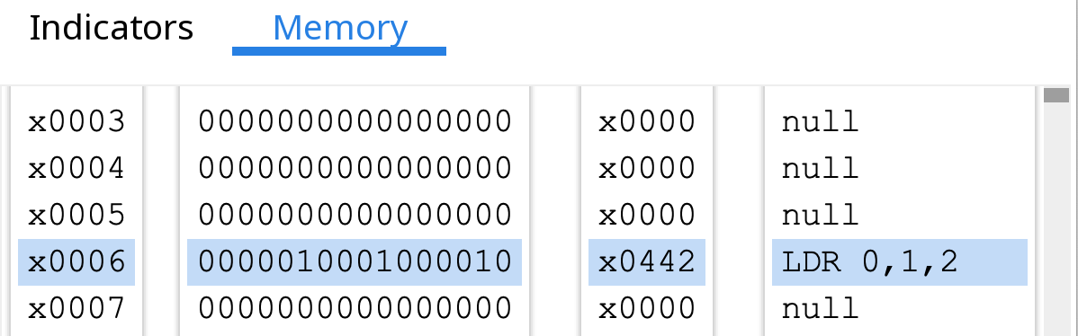

**Step 2**: Write the address of the instruction to the Program Counter (PC).



**Step 3**: Click the ‘Single Run’ button, and then the instruction will be executed.

* The Program Counter will automatically point to the next address of Memory.
* The Instruction Register will store the last executed instruction.

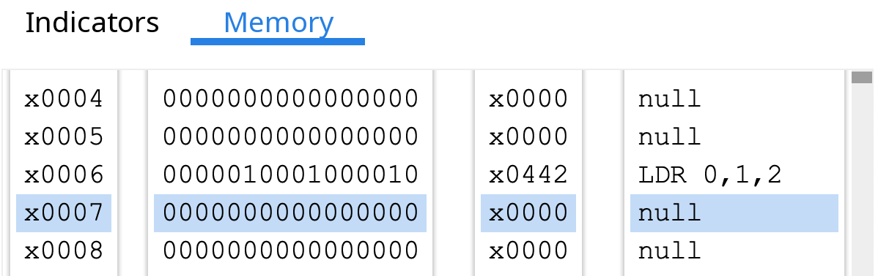

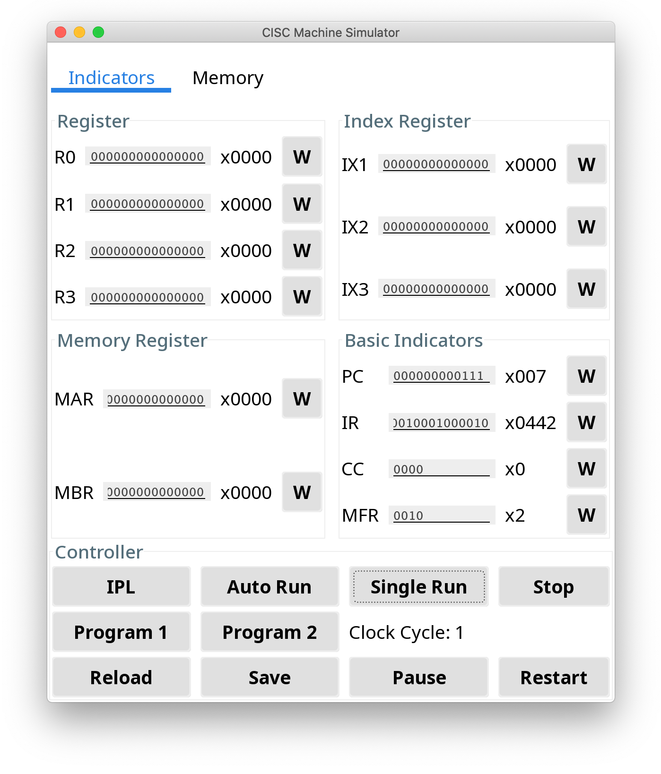

### 3.4.2 Executing Instructions Automatically

**Step 1**: Store instructions to the Memory.

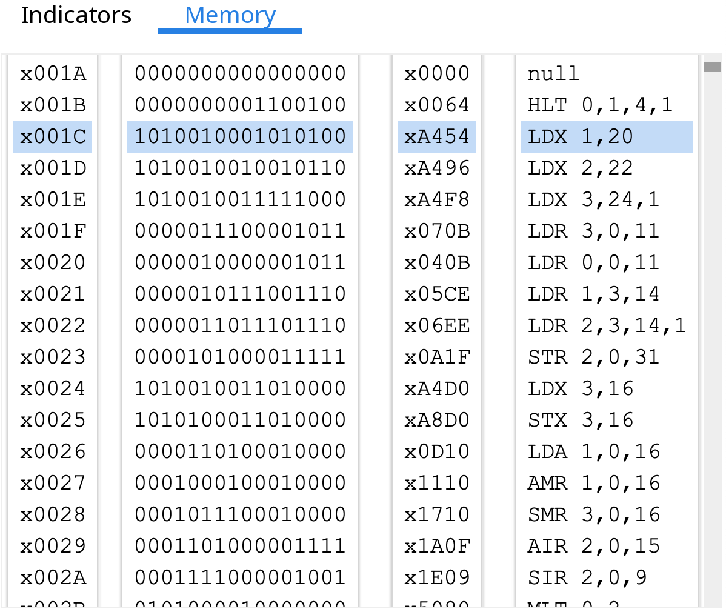

**Step 2**: Write the address of the **starting** instruction to the Program Counter (PC).



**Step 3**: Click the ‘Auto Run’ button, and then the instructions will be executed automatically.

* The Program Counter will automatically point to the next address of Memory after an instruction being executed.
* All the indicators will be continuously updated while the program is running.

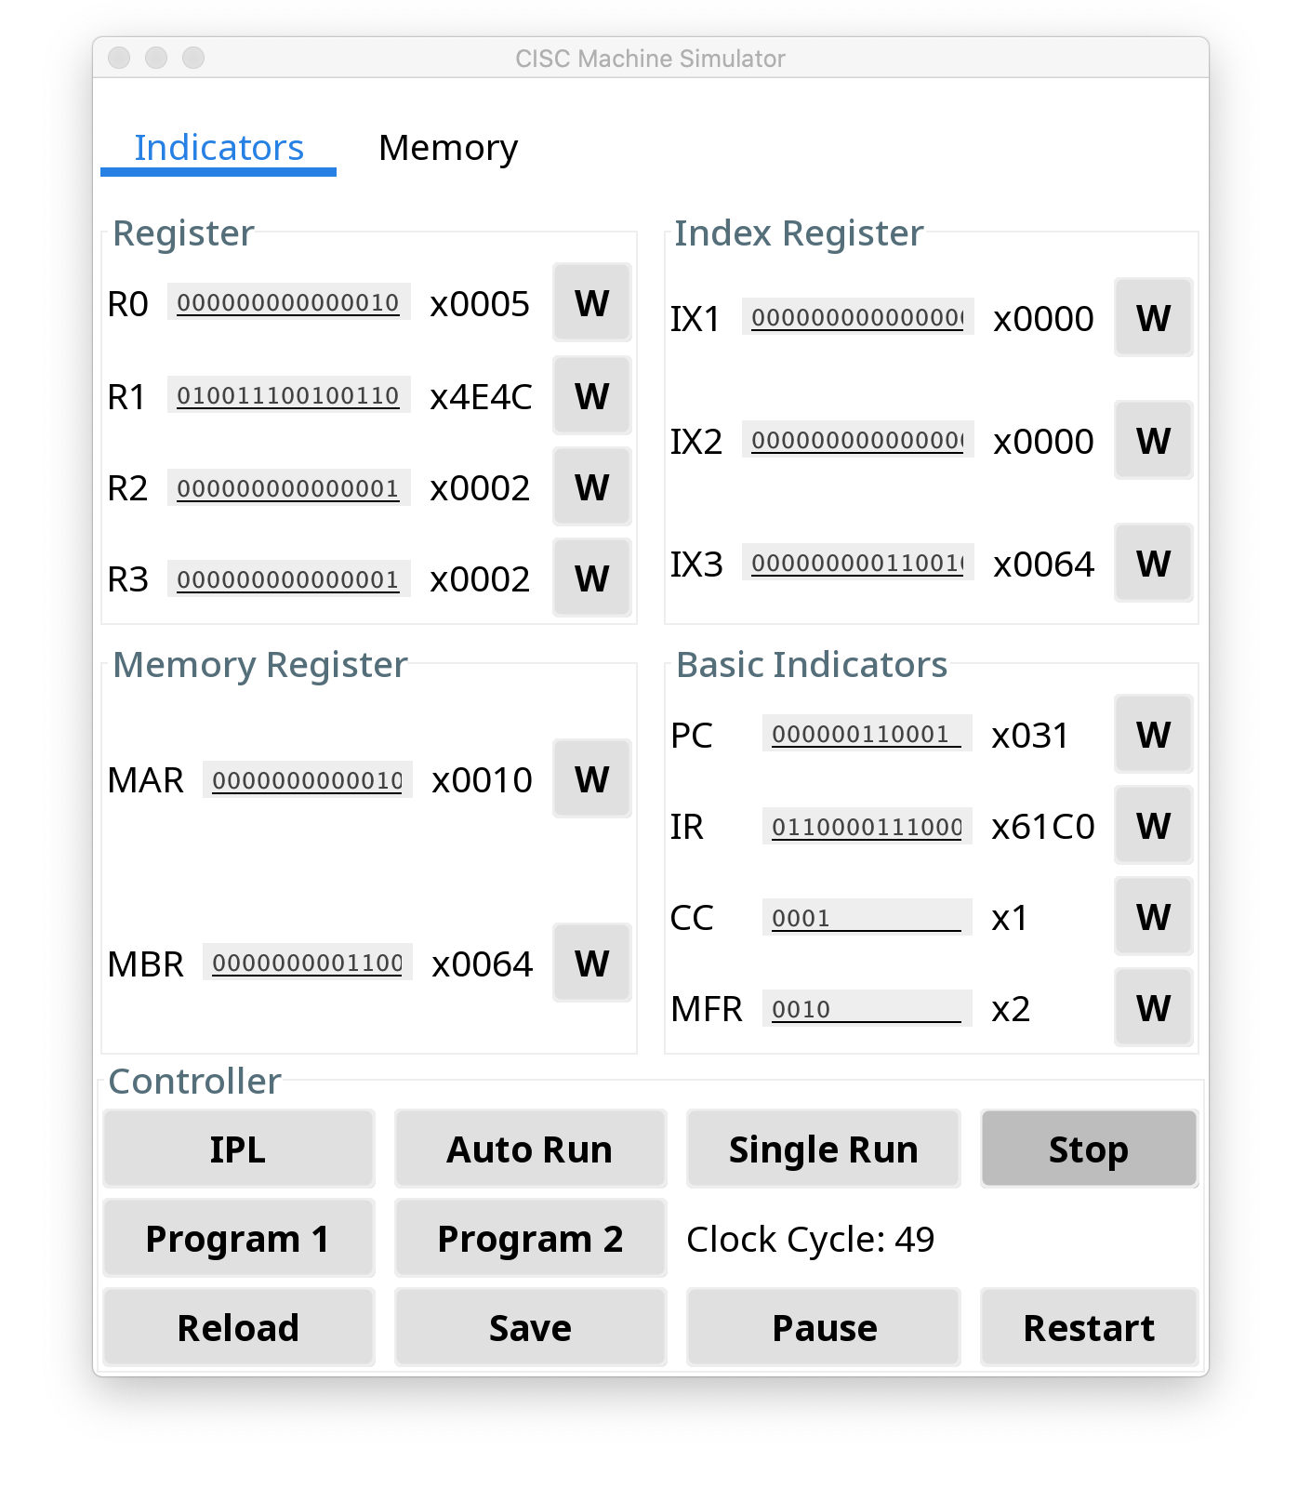

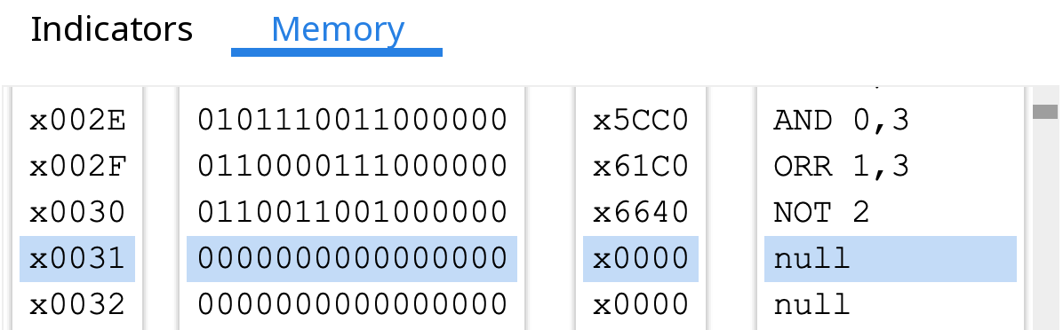

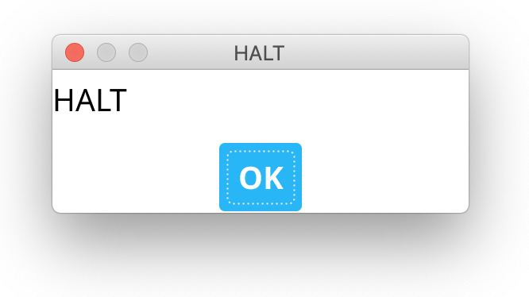

**Step 4**: Click the ‘Pause’ button to pause the program or the ‘Stop’ button to stop the program.

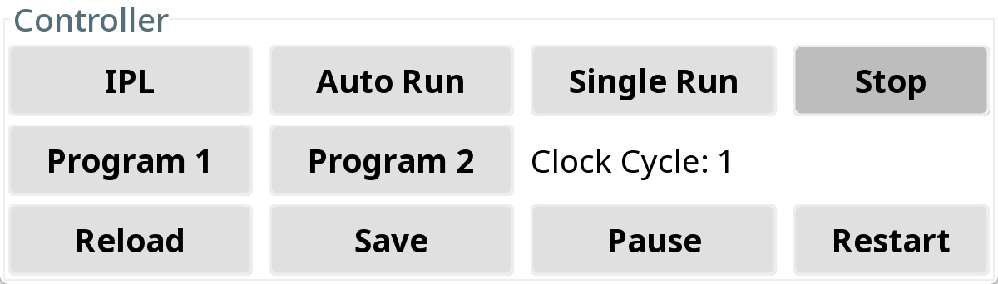

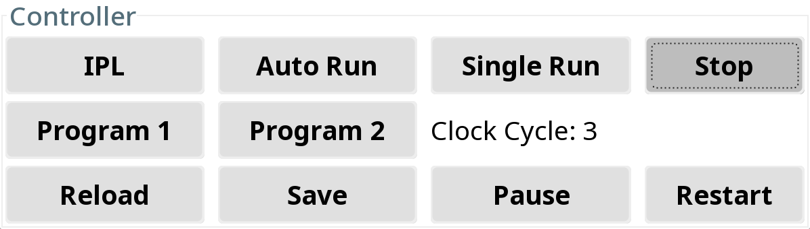

# 4 Executing Programs

## 4.1 Executing Program 1

### 4.1.1 Program 1 Description

Program 1 is a program that reads 20 numbers (integers) from the keyboard, prints the numbers to the console printer, requests a number from the user, and searches the 20 numbers read in for the number closest to the number entered by the user. The numbers distributed over the range of 0 … 65535. Print the number entered by the user and the number closest to that number.

### 4.1.2 Program 1 Files

**Program 1.assemble** is the program that was written in assembly language.

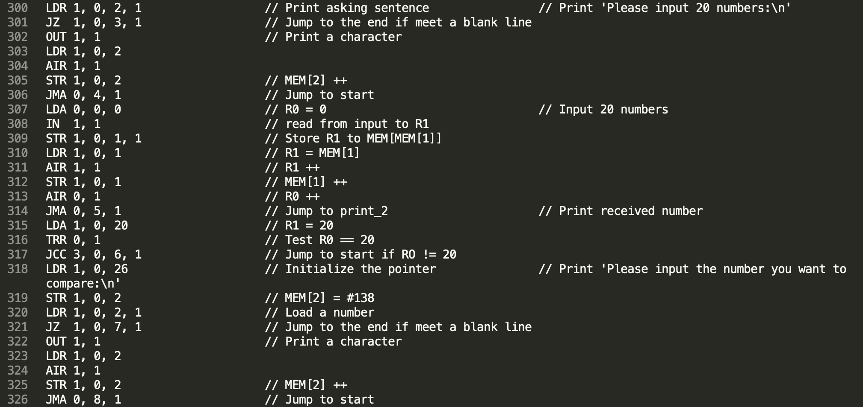

**Program 1.program** is the program that has been translated to binary machine codes.

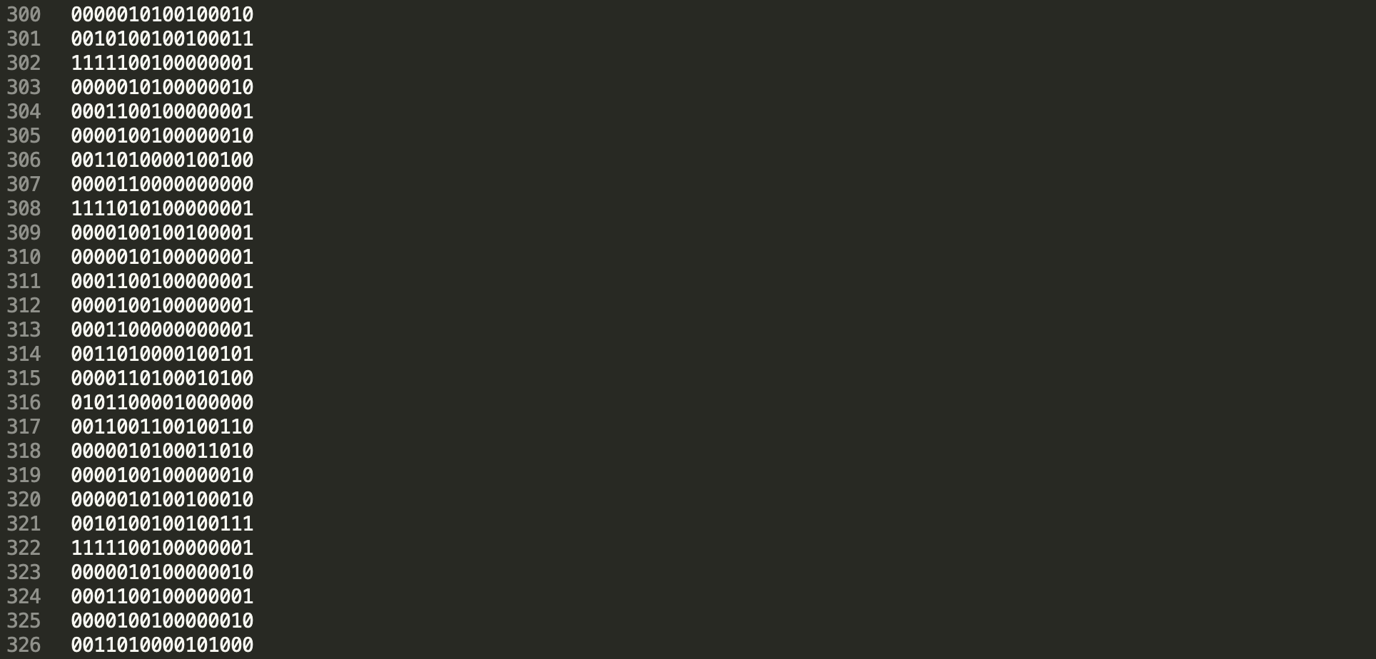

### 4.1.3 Running Program 1

**Step 1**: Input ‘program 1’ or ‘program1’ in the **Operation Panel (Console)** and then click the ‘Enter’ button. Or click the ‘Program 1’ button in the **Debugging Panel**.



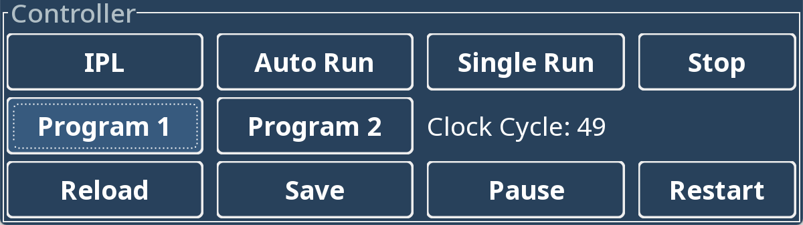

**Step 2**: Input numbers (use comma to split numbers) and then click the ‘Enter’ button. You can fill the numbers several times to input the required 20 numbers.

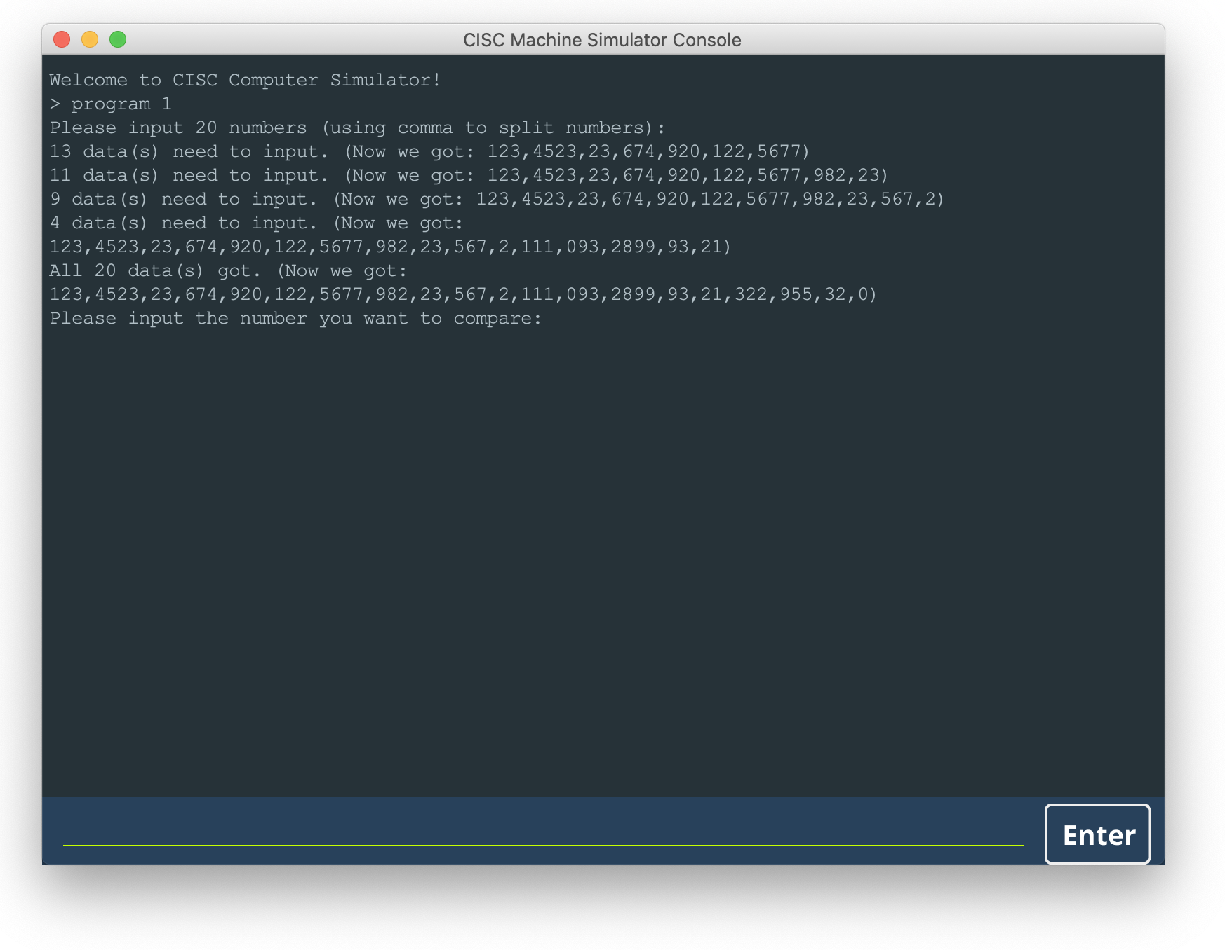

**Step 3**: Input the number for comparing.

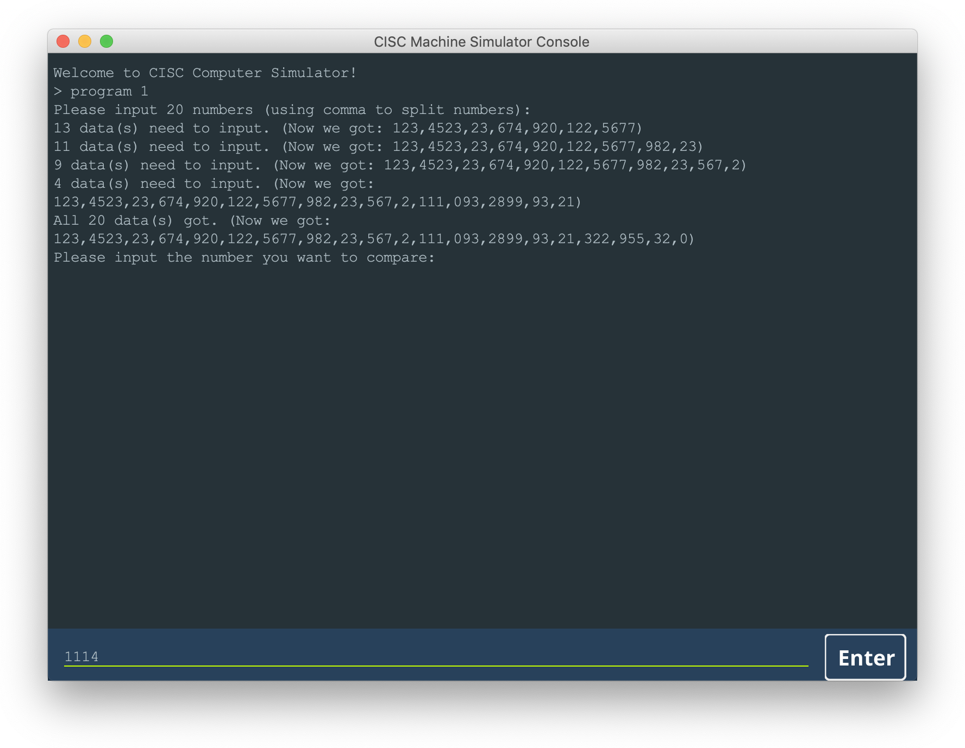

**Step 4**: Done! The result of the calculation will be output to the **Console**.

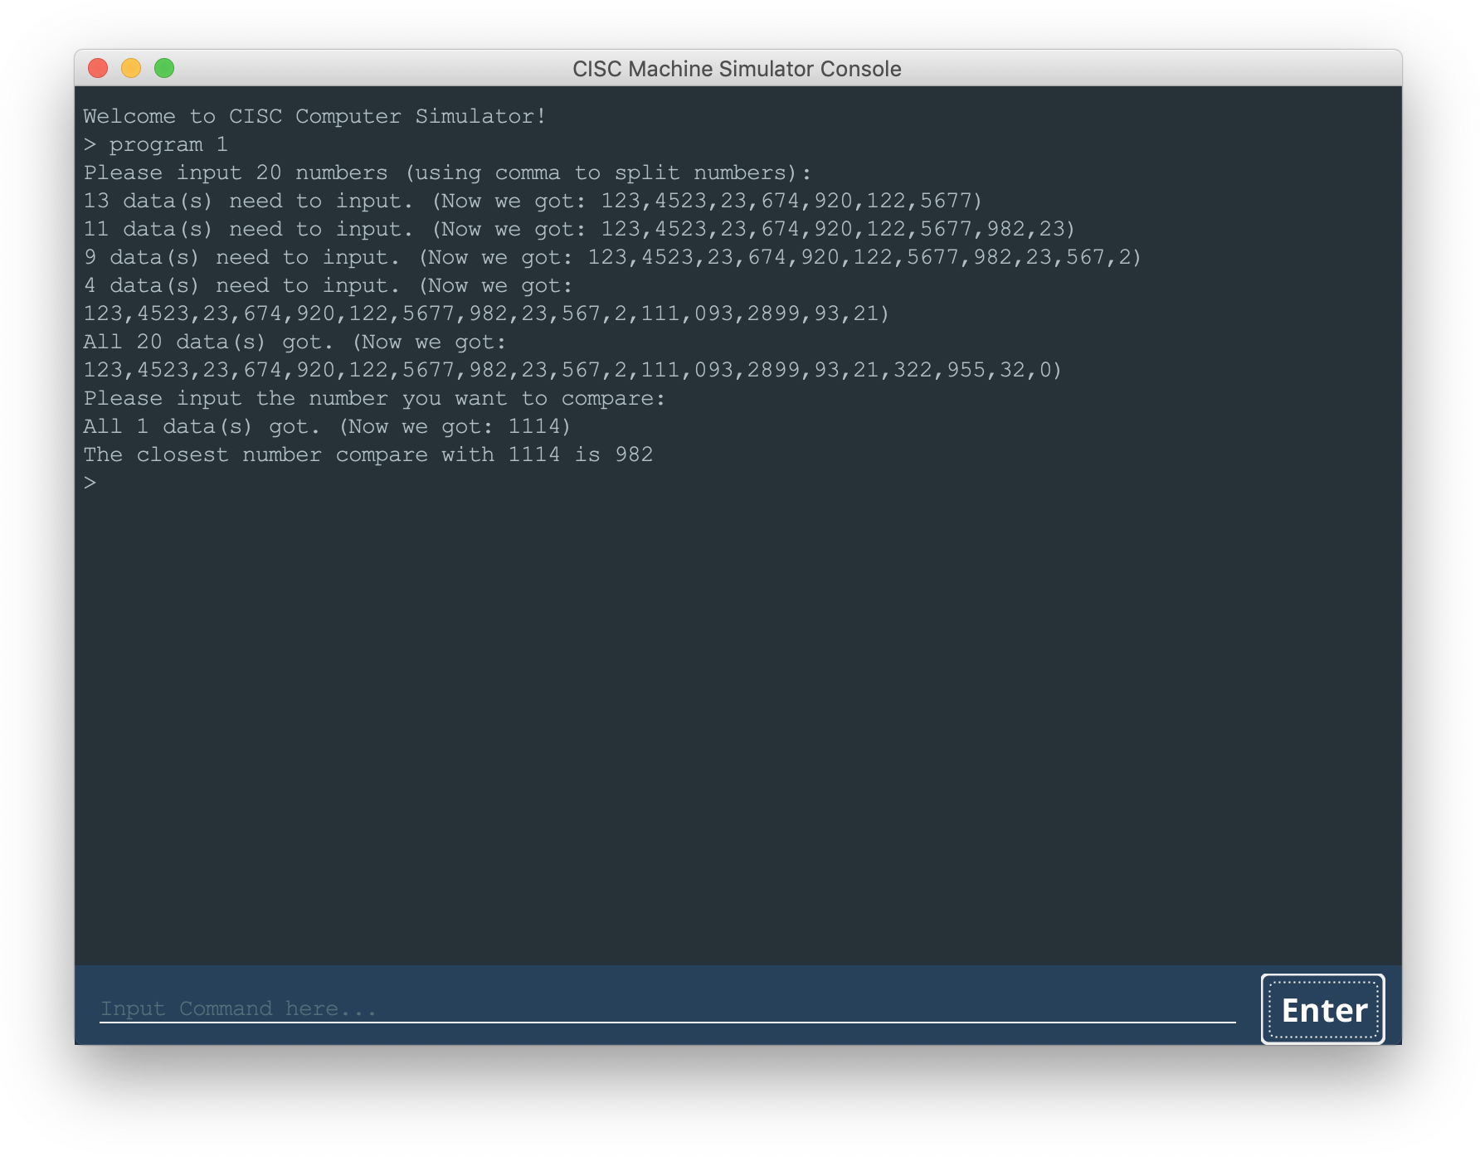

## 4.2 Executing Program 2

### 4.2.1 Program 2 Description

Program 2 is a program that reads a set of a paragraph of 6 sentences from a file into memory. It prints the sentences on the console printer. It then asks the user for a word. It searches the paragraph to see if it contains the word. If so, it prints out the word, the sentence number, and the word number in the sentence.

### 4.2.2 Program 2 Files

**Program 2.assemble** is the program that was written in assembly language.

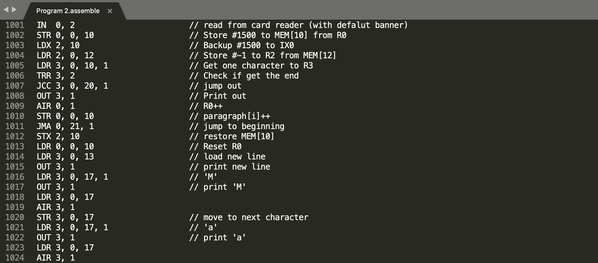

**Program 2.program** is the program that has been translated to binary machine codes.

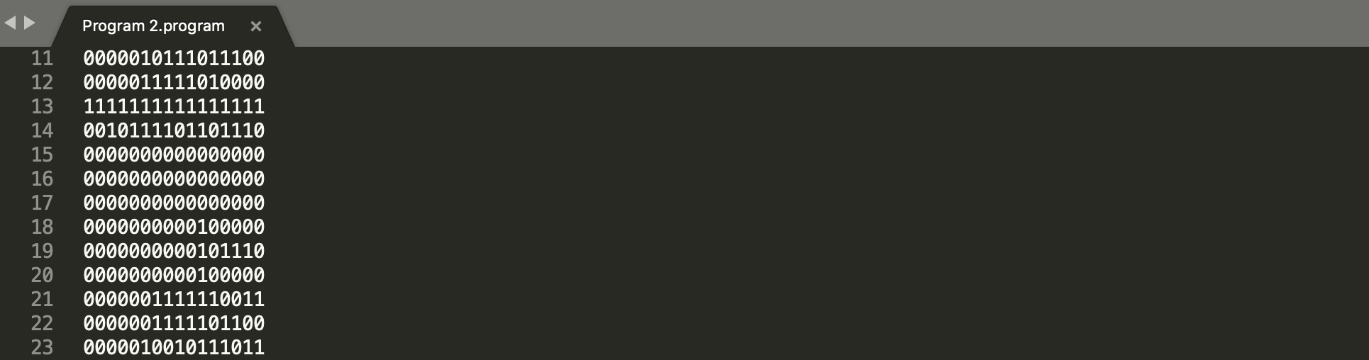

**Program 2_Paragraph.card** is the input card file, which contains the paragraph for program 2.

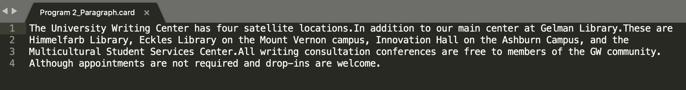

### 4.2.3 Running Program 2

**Step 1**: Write a paragraph of 6 sentences into the card file ‘Program 2_Paragraph.card’.



**Step 2**: Input ‘program 2’ or ‘program2’ in the **Operation Panel (Console)** and then click the ‘Enter’ button. Or click the ‘Program 2’ button in the **Debugging Panel**.

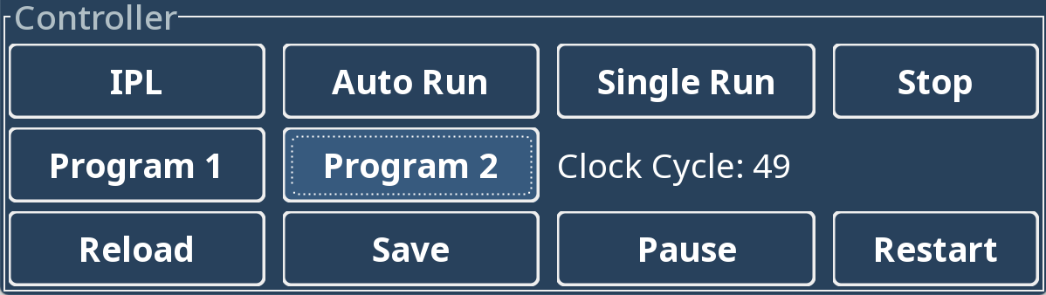



**Step 3**: The program 2 will be loaded from the program file ‘Program 2.program’ to Memory. Input ‘autorun’ or ‘auto run’ in the **Console** and then click the ‘Enter’ button. Or click the ‘Auto Run’ button in the **Debugging Panel**.

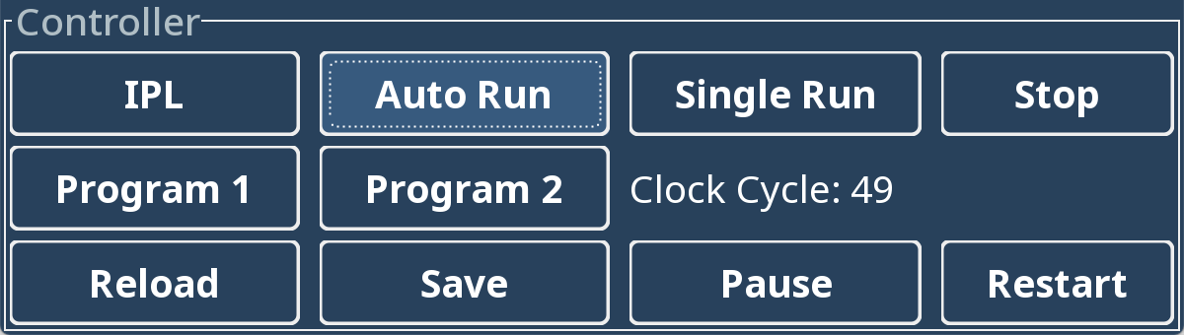

**Step 4**: A window will pop up, asking for inserting a card. Choose the card file ‘Program 2_Paragraph.card’ as the input card and insert it. Then, the paragraph will be loaded from the card file to the machine, using Card Reader as the input device, and will be displayed in the **Console**.Note that the reading process will last for **a few minutes**.

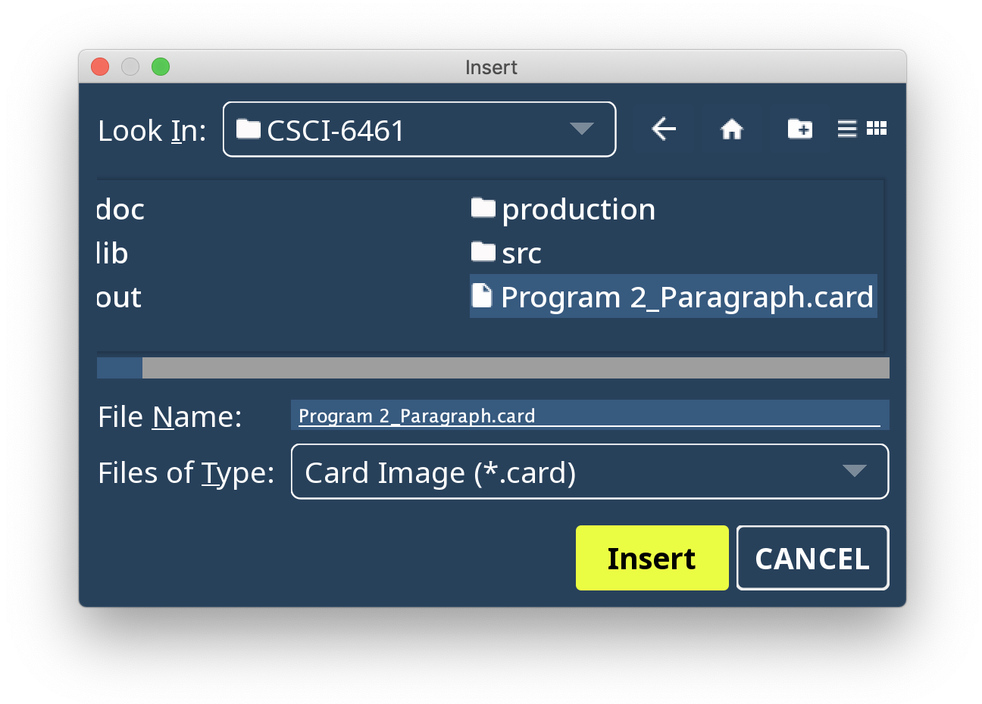

**Step 4**: Input the word to be matched to the paragraph in the **Console** and then click the ‘Enter’ button.

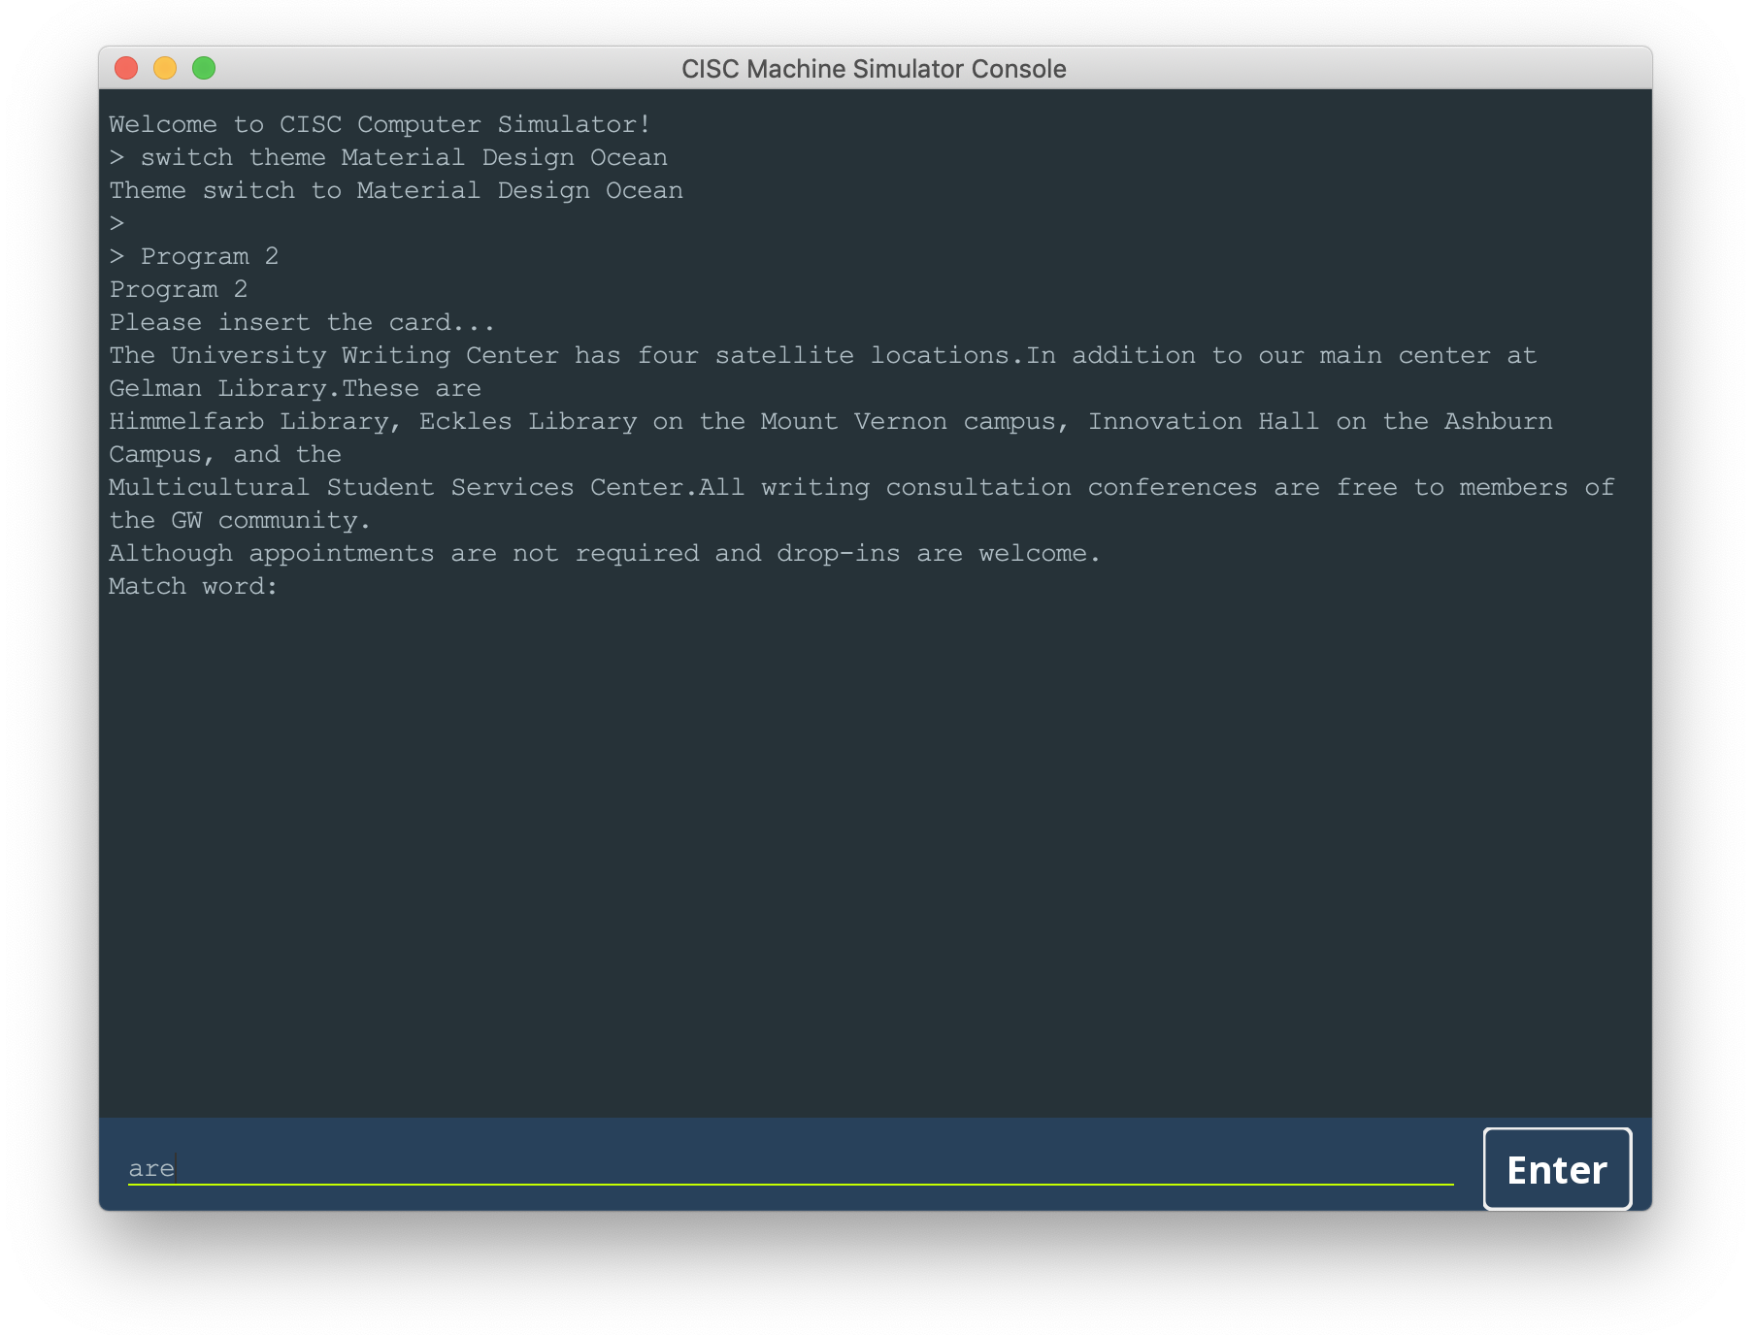

**Step 5**: The machine will start the calculation process, which will last for **a few minutes**. Then, the **Console** will print out the word, the sentence index in the paragraph, and the word index in the sentence. **Note that the index starts from 0 rather than 1.**

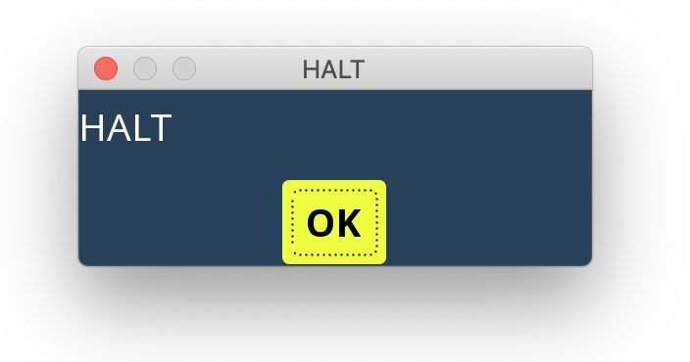

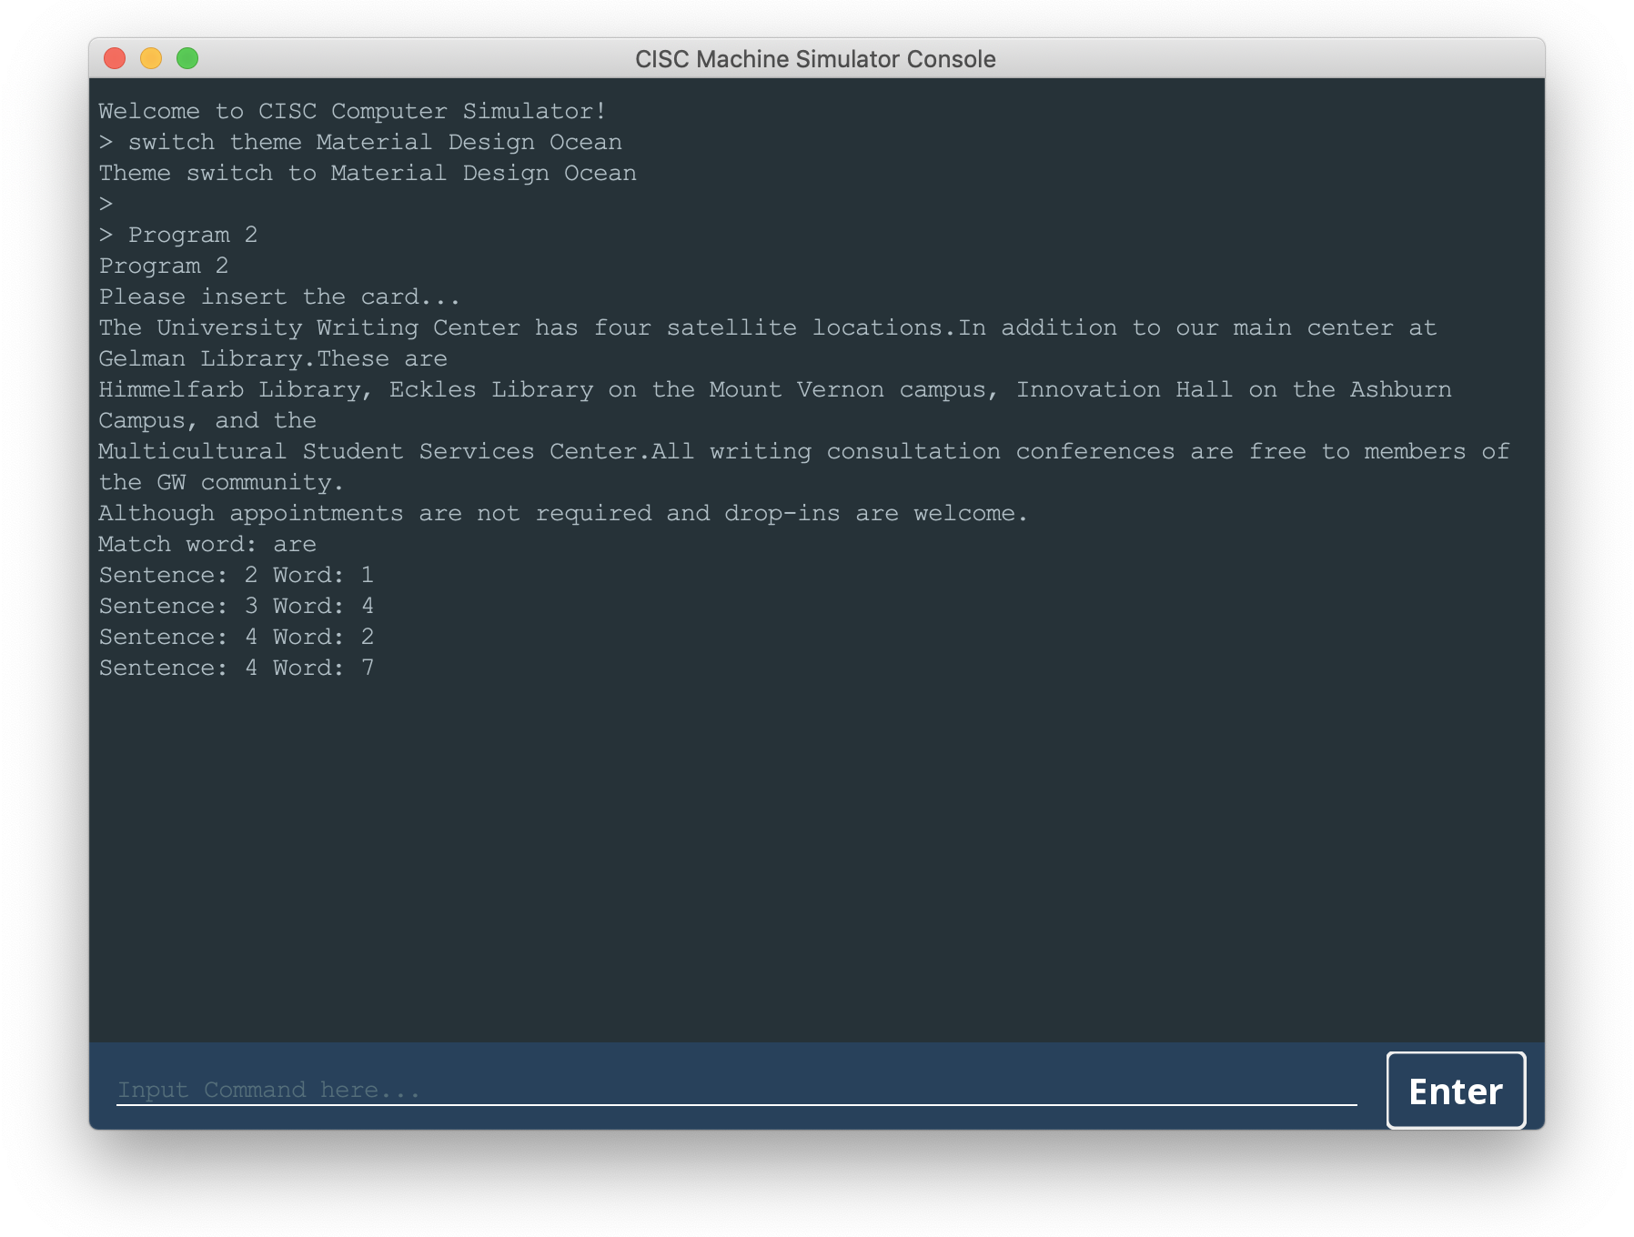

## 4.3 Executing a Custom Program Using IPL

### 4.3.1 Using Operation Panel (Console)

**Step 1**: Write the custom program in a ‘.program’ file, using binary machine code.

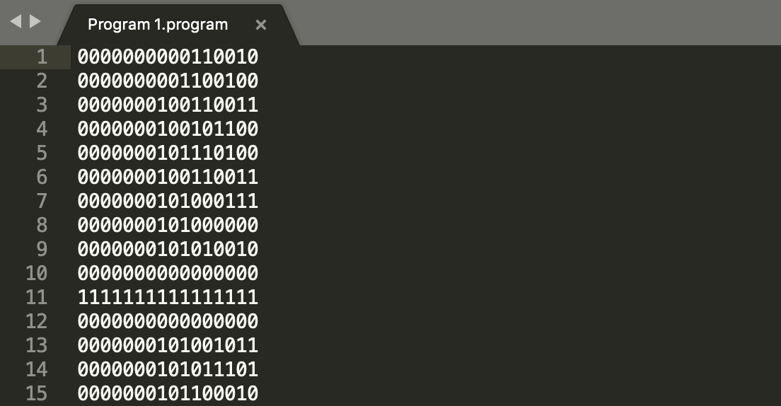

**Step 2**: Input ‘ipl’ command to the console to import the program to the memory.



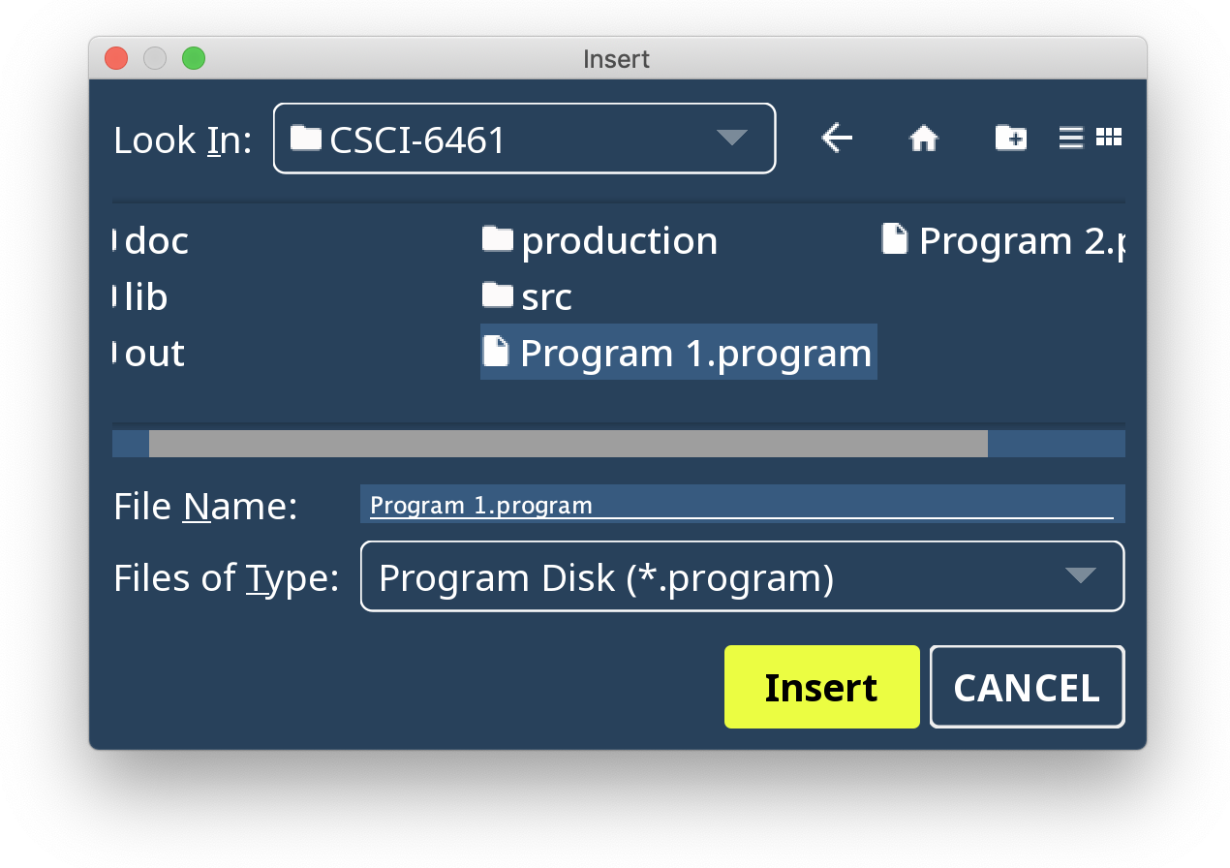

**Step 4**: Input ‘auto run’ or ‘autorun’ command to the console, and then the program will be executed. Or input ‘single run’ or ‘singlerun’ command to run the program step-by-step.





### 4.3.2 Using Debugging Panel

**Step 1**: Write the custom program in a ‘.program’ file, using binary machine code.



**Step 2**: Click the ‘IPL’ button to import the program to the memory.

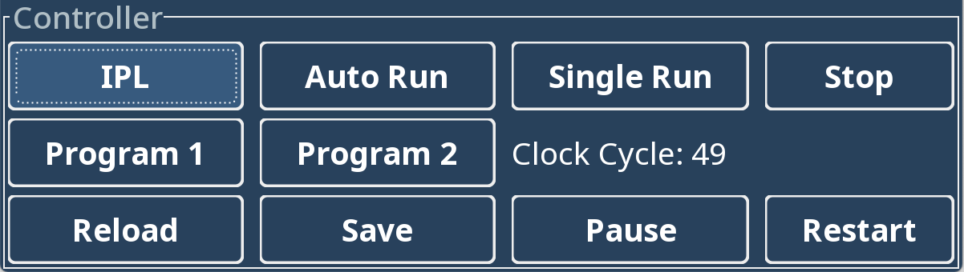



**Step 3**: Click the ‘Auto Run’ button, and then the program will be executed. Or click the ‘Single Run’ button to run the program step-by-step.



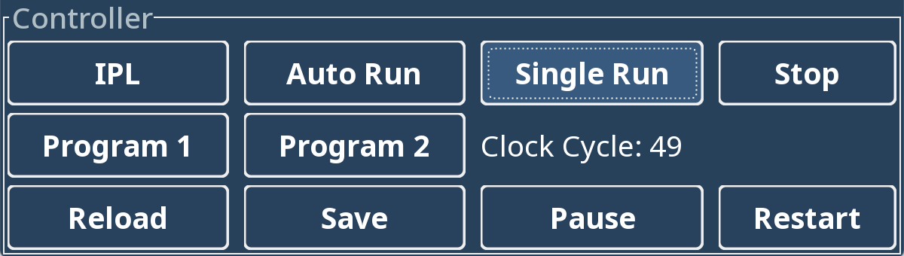

# 5 Instructions Reference

## 5.1 Load/Store Instructions

The instructions to load/store values from/to Registers or Memory.

The binary instruction code format of Load/Store Instructions is as follows:

|  |  |  |  |  |
| --- | --- | --- | --- | --- |
| Opcode | R | IX | I | Address |
| 0 5 | 6 7 | 8 9 | 1  0 | 1 1  1 5 |

|  |  |  |
| --- | --- | --- |
| **Opcode:** | 6 bits | Specifies the instruction |
| **R:** | 2 bits | Specifies the General-Purpose Register |
| **IX:** | 2 bits | Specifies the Index Register |
| **I:** | 1 bit | Specifies Indirect Addressing  If I =1, indirect addressing; otherwise, no indirect addressing. |
| **Address:** | 5 bits | Specifies the location |

### 5.1.1 (01) LDR

|  |  |  |  |  |
| --- | --- | --- | --- | --- |
| 000001 | R | IX | I | Address |
| 0 5 | 6 7 | 8 9 | 1  0 | 1 1  1 5 |

|  |  |
| --- | --- |
| Instruction: | LDR r, x, address[, I] |
| Octal-Opcode: | 01 |
| Binary-Opcode: | 000001 |
| Function: | Loads Register from Memory |
| Notes: | r = 0...3  r <- c(EA)  r <- c(c(EA)), if I bit set |

### 5.1.2 (02) STR

|  |  |  |  |  |
| --- | --- | --- | --- | --- |
| 000010 | R | IX | I | Address |
| 0 5 | 6 7 | 8 9 | 1  0 | 1 1  1 5 |

|  |  |
| --- | --- |
| Instruction: | STR r, x, address[, I] |
| Octal-Opcode: | 02 |
| Binary-Opcode: | 000010 |
| Function: | Stores Register to Memory |
| Notes: | r = 0...3  Memory(EA) <- c(r) |

### 5.1.3 (03) LDA

|  |  |  |  |  |
| --- | --- | --- | --- | --- |
| 000011 | R | IX | I | Address |
| 0 5 | 6 7 | 8 9 | 1  0 | 1 1  1 5 |

|  |  |
| --- | --- |
| Instruction: | LDA r, x, address[, I] |
| Octal-Opcode: | 03 |
| Binary-Opcode: | 000011 |
| Function: | Loads Register with Address |
| Notes: | r = 0...3  r <- EA |

### 5.1.4 (41) LDX

|  |  |  |  |  |
| --- | --- | --- | --- | --- |
| 101001 |  | IX | I | Address |
| 0 5 | 6 7 | 8 9 | 1  0 | 1 1  1 5 |

|  |  |
| --- | --- |
| Instruction: | LDX x, address[, I] |
| Octal-Opcode: | 41 |
| Binary-Opcode: | 101001 |
| Function: | Loads Index Register from Memory |
| Notes: | Xx <- c(EA) |

### 5.1.5 (42) STX

|  |  |  |  |  |
| --- | --- | --- | --- | --- |
| 101010 |  | IX | I | Address |
| 0 5 | 6 7 | 8 9 | 1  0 | 1 1  1 5 |

|  |  |
| --- | --- |
| Instruction: | STX x, address[, I] |
| Octal-Opcode: | 42 |
| Binary-Opcode: | 101010 |
| Function: | Stores Index Register to Memory |
| Notes: | Memory(EA) <- c(Xx) |

## 5.2 Arithmetic and Logical Instructions

The instructions to perform most of the computational works in the machine.

The binary instruction code format of basic Arithmetic and Logical Instructions is as follows:

|  |  |  |  |  |
| --- | --- | --- | --- | --- |
| Opcode | R | IX | I | Address |
| 0 5 | 6 7 | 8 9 | 1  0 | 1 1  1 5 |

|  |  |  |
| --- | --- | --- |
| **Opcode:** | 6 bits | Specifies the instruction |
| **R:** | 2 bits | Specifies the General-Purpose Register |
| **IX:** | 2 bits | Specifies the Index Register |
| **I:** | 1 bit | Specifies Indirect Addressing  If I =1, indirect addressing; otherwise, no indirect addressing. |
| **Address:** | 5 bits | Specifies the location |

The binary instruction code format of register-to-register Arithmetic and Logical Instructions is as follows:

|  |  |  |  |
| --- | --- | --- | --- |
| Opcode | Rx | Ry |  |
| 0 5 | 6 7 | 8 9 | 1 1  0 5 |

|  |  |  |
| --- | --- | --- |
| **Opcode:** | 6 bits | Specifies the instruction |
| **Rx:** | 2 bits | Specifies the General-Purpose Register x |
| **Ry:** | 2 bits | Specifies the General-Purpose Register y |

### 5.2.1 (04) AMR

|  |  |  |  |  |
| --- | --- | --- | --- | --- |
| 000100 | R | IX | I | Address |
| 0 5 | 6 7 | 8 9 | 1  0 | 1 1  1 5 |

|  |  |
| --- | --- |
| Instruction: | AMR r, x, address[, I] |
| Octal-Opcode: | 04 |
| Binary-Opcode: | 000100 |
| Function: | Add Memory to Register |
| Notes: | r = 0...3  r <- c(r) + c(EA) |

### 5.2.2 (05) SMR

|  |  |  |  |  |
| --- | --- | --- | --- | --- |
| 000101 | R | IX | I | Address |
| 0 5 | 6 7 | 8 9 | 1  0 | 1 1  1 5 |

|  |  |
| --- | --- |
| Instruction: | SMR r, x, address[, I] |
| Octal-Opcode: | 05 |
| Binary-Opcode: | 000101 |
| Function: | Subtract Memory from Register |
| Notes: | r = 0...3  r <- c(r) - c(EA) |

### 5.2.3 (06) AIR

|  |  |  |  |  |
| --- | --- | --- | --- | --- |
| 000110 | R |  |  | Immed |
| 0 5 | 6 7 | 8 9 | 1  0 | 1 1  1 5 |

|  |  |
| --- | --- |
| Instruction: | AIR r, immed |
| Octal-Opcode: | 06 |
| Binary-Opcode: | 000110 |
| Function: | Add Immediate to Register |
| Notes: | r = 0...3  r <- c(r) + Immed  if Immed = 0, does nothing  if c(r) = 0, loads r with Immed |

### 5.2.4 (07) SIR

|  |  |  |  |  |
| --- | --- | --- | --- | --- |
| 000111 | R |  |  | Immed |
| 0 5 | 6 7 | 8 9 | 1  0 | 1 1  1 5 |

|  |  |
| --- | --- |
| Instruction: | SIR r, immed |
| Octal-Opcode: | 07 |
| Binary-Opcode: | 000111 |
| Function: | Subtract Immediate from Register |
| Notes: | r = 0...3  r <- c(r) - Immed  if Immed = 0, does nothing  if c(r) = 0, loads R1 with -(Immed) |

### 5.2.5 (20) MLT

|  |  |  |  |
| --- | --- | --- | --- |
| 010100 | Rx | Ry |  |
| 0 5 | 6 7 | 8 9 | 1 1  0 5 |

|  |  |
| --- | --- |
| Instruction: | MLT rx, ry |
| Octal-Opcode: | 20 |
| Binary-Opcode: | 010100 |
| Function: | Multiply Register by Register |
| Notes: | rx, rx+1 <- c(rx) * c(ry)  rx, ry must be 0 or 2  rx contains the high order bits  rx+1 contains the low order bits of the result  Set OVERFLOW flag, if overflow |

### 5.2.6 (21) DVD

|  |  |  |  |
| --- | --- | --- | --- |
| 010101 | Rx | Ry |  |
| 0 5 | 6 7 | 8 9 | 1 1  0 5 |

|  |  |
| --- | --- |
| Instruction: | DVD rx, ry |
| Octal-Opcode: | 21 |
| Binary-Opcode: | 010101 |
| Function: | Divide Register by Register |
| Notes: | rx, rx+1 <- c(rx) / c(ry)  rx, ry must be 0 or 2  rx contains the quotient; rx+1 contains the remainder  If c(ry) = 0, set cc(3) to 1 (set DIVZERO flag) |

### 5.2.7 (22) TRR

|  |  |  |  |
| --- | --- | --- | --- |
| 010110 | Rx | Ry |  |
| 0 5 | 6 7 | 8 9 | 1 1  0 5 |

|  |  |
| --- | --- |
| Instruction: | TRR rx, ry |
| Octal-Opcode: | 22 |
| Binary-Opcode: | 010110 |
| Function: | Test the Equality of Register and Register |
| Notes: | If c(rx) = c(ry), set cc(4) <- 1;  Else, cc(4) <- 0 |

### 5.2.8 (23) AND

|  |  |  |  |
| --- | --- | --- | --- |
| 010111 | Rx | Ry |  |
| 0 5 | 6 7 | 8 9 | 1 1  0 5 |

|  |  |
| --- | --- |
| Instruction: | AND rx, ry |
| Octal-Opcode: | 23 |
| Binary-Opcode: | 010111 |
| Function: | Logical AND of Register and Register |
| Notes: | c(rx) <- c(rx) AND c(ry) |

### 5.2.9 (24) ORR

|  |  |  |  |
| --- | --- | --- | --- |
| 011000 | Rx | Ry |  |
| 0 5 | 6 7 | 8 9 | 1 1  0 5 |

|  |  |
| --- | --- |
| Instruction: | ORR rx, ry |
| Octal-Opcode: | 24 |
| Binary-Opcode: | 011000 |
| Function: | Logical OR of Register and Register |
| Notes: | c(rx) <- c(rx) OR c(ry) |

### 5.2.10 (25) NOT

|  |  |  |
| --- | --- | --- |
| 011001 | Rx |  |
| 0 5 | 6 7 | 8 1  5 |

|  |  |
| --- | --- |
| Instruction: | NOT rx |
| Octal-Opcode: | 25 |
| Binary-Opcode: | 011001 |
| Function: | Logical NOT of Register to Register |
| Notes: | C(rx) <- NOT c(rx) |

## 5.3 Transfer Instructions

The instructions to check the value of a register and then change the control of program execution.

The binary instruction code format of Transfer Instructions is as follows:

|  |  |  |  |  |
| --- | --- | --- | --- | --- |
| Opcode | R | IX | I | Address |
| 0 5 | 6 7 | 8 9 | 1  0 | 1 1  1 5 |

|  |  |  |
| --- | --- | --- |
| **Opcode:** | 6 bits | Specifies the instruction |
| **R:** | 2 bits | Specifies the General-Purpose Register |
| **IX:** | 2 bits | Specifies the Index Register |
| **I:** | 1 bit | Specifies Indirect Addressing  If I =1, indirect addressing; otherwise, no indirect addressing. |
| **Address:** | 5 bits | Specifies the location |

### 5.3.1 (10) JZ

|  |  |  |  |  |
| --- | --- | --- | --- | --- |
| 001010 | R | IX | I | Address |
| 0 5 | 6 7 | 8 9 | 1  0 | 1 1  1 5 |

|  |  |
| --- | --- |
| Instruction: | JZ r, x, address[, I] |
| Octal-Opcode: | 10 |
| Binary-Opcode: | 001010 |
| Function: | Jump if Zero |
| Notes: | r = 0...3  If c(r) = 0, then PC <- EA; Else PC <- PC+1 |

### 5.3.2 (11) JNE

|  |  |  |  |  |
| --- | --- | --- | --- | --- |
| 001011 | R | IX | I | Address |
| 0 5 | 6 7 | 8 9 | 1  0 | 1 1  1 5 |

|  |  |
| --- | --- |
| Instruction: | JNE r, x, address[, I] |
| Octal-Opcode: | 11 |
| Binary-Opcode: | 001011 |
| Function: | Jump if Not Equal |
| Notes: | r = 0...3  If c(r) != 0, then PC <- EA;  Else PC <- PC + 1 |

### 5.3.3 (12) JCC

|  |  |  |  |  |
| --- | --- | --- | --- | --- |
| 001100 | CC | IX | I | Address |
| 0 5 | 6 7 | 8 9 | 1  0 | 1 1  1 5 |

|  |  |
| --- | --- |
| Instruction: | JCC cc, x, address[, I] |
| Octal-Opcode: | 12 |
| Binary-Opcode: | 001100 |
| Function: | Jump if Condition Code |
| Notes: | cc = 0...3, specifies the bit in the Condition Code Register to check  If cc = 1, PC <- EA; Else PC <- PC + 1 |

### 5.3.4 (13) JMA

|  |  |  |  |  |
| --- | --- | --- | --- | --- |
| 001101 |  | IX | I | Address |
| 0 5 | 6 7 | 8 9 | 1  0 | 1 1  1 5 |

|  |  |
| --- | --- |
| Instruction: | JMA x, address[, I] |
| Octal-Opcode: | 13 |
| Binary-Opcode: | 001101 |
| Function: | Unconditional Jump to Address |
| Notes: | PC <- EA |

### 5.3.5 (14) JSR

|  |  |  |  |  |
| --- | --- | --- | --- | --- |
| 001110 |  | IX | I | Address |
| 0 5 | 6 7 | 8 9 | 1  0 | 1 1  1 5 |

|  |  |
| --- | --- |
| Instruction: | JSR x, address[, I] |
| Octal-Opcode: | 14 |
| Binary-Opcode: | 001110 |
| Function: | Jump and Save Return Address |
| Notes: | R3 <- PC+1  PC <- EA  R0 should contain pointer to arguments  Argument list should end with -1 (all 1s) value |

### 5.3.6 (15) RFS

|  |  |  |  |  |
| --- | --- | --- | --- | --- |
| 001111 |  |  |  | Immed |
| 0 5 | 6 7 | 8 9 | 1  0 | 1 1  1 5 |

|  |  |
| --- | --- |
| Instruction: | RFS immed |
| Octal-Opcode: | 15 |
| Binary-Opcode: | 001111 |
| Function: | Return from Subroutine with Return Code as Immediate Portion (optional) Stored in the Instruction’s Address Field |
| Notes: | R0 <- Immed  PC <- c(R3) |

### 5.3.7 (16) SOB

|  |  |  |  |  |
| --- | --- | --- | --- | --- |
| 010000 | R | IX | I | Address |
| 0 5 | 6 7 | 8 9 | 1  0 | 1 1  1 5 |

|  |  |
| --- | --- |
| Instruction: | SOB r, x, address[, I] |
| Octal-Opcode: | 16 |
| Binary-Opcode: | 010000 |
| Function: | Subtract One and Branch |
| Notes: | r = 0...3  r <- c(r) - 1  If c(r) > 0, PC <- EA;  Else PC <- PC + 1 |

### 5.3.8 (17) JGE

|  |  |  |  |  |
| --- | --- | --- | --- | --- |
| 010001 | R | IX | I | Address |
| 0 5 | 6 7 | 8 9 | 1  0 | 1 1  1 5 |

|  |  |
| --- | --- |
| Instruction: | JGE r, x, address[, I] |
| Octal-Opcode: | 17 |
| Binary-Opcode: | 010001 |
| Function: | Jump Greater than or Equal to |
| Notes: | If c(r) >= 0, then PC <- EA; Else PC <- PC + 1 |

## 5.4 Shift/Rotate Instructions

The instructions to manipulate a datum in a register.

The binary instruction code format of Shift and Rotate Instructions is as follows:

|  |  |  |  |  |  |
| --- | --- | --- | --- | --- | --- |
| Opcode | R | A/L | L/R |  | Count |
| 0 5 | 6 7 | 8 | 9 | 1 1  0 1 | 1 1  2 5 |

|  |  |  |
| --- | --- | --- |
| **Opcode:** | 6 bits | Specifies the instruction |
| **R:** | 2 bits | Specifies the General-Purpose Register |
| **A/L:** | 2 bits | Arithmetic Shift (A/L = 0); Logical Shift (A/L = 1) |
| **L/R:** | 2 bits | Logical Rotate (L/R = 1) |
| **Count:** | 4 bits | Specifies the Count for Operation |

### 5.4.1 (31) SRC

|  |  |  |  |  |  |
| --- | --- | --- | --- | --- | --- |
| Opcode | R | A/L | L/R |  | Count |
| 0 5 | 6 7 | 8 | 9 | 1 1  0 1 | 1 1  2 5 |

|  |  |
| --- | --- |
| Instruction: | SRC r, count, L/R, A/L |
| Octal-Opcode: | 31 |
| Binary-Opcode: | 011111 |
| Function: | Shift Register by Count |
| Notes: | c(r) is shifted left (L/R =1) or right (L/R = 0) either logically (A/L = 1) or arithmetically (A/L = 0)  Count = 0...15; If Count = 0, no shift occurs |

### 5.4.2 (32) RRC

|  |  |  |  |  |  |
| --- | --- | --- | --- | --- | --- |
| Opcode | R | A/L | L/R |  | Count |
| 0 5 | 6 7 | 8 | 9 | 1 1  0 1 | 1 1  2 5 |

|  |  |
| --- | --- |
| Instruction: | RRC r, count, L/R, A/L |
| Octal-Opcode: | 32 |
| Binary-Opcode: | 100000 |
| Function: | Rotate Register by Count |
| Notes: | c(r) is rotated left (L/R = 1) or right (L/R =0) either logically (A/L =1)  Count = 0...15 |

## 5.5 Floating Point and Vector Instructions

The instructions for calculation of floating points and vectors.

The binary instruction code format of Floating Point and Vector Instructions is as follows:

|  |  |  |  |  |
| --- | --- | --- | --- | --- |
| Opcode | FR | IX | I | Address |
| 0 5 | 6 7 | 8 9 | 1  0 | 1 1  1 5 |

|  |  |  |
| --- | --- | --- |
| **Opcode:** | 6 bits | Specifies the instruction |
| **FR:** | 2 bis | Specifies the Floating Point Register |
| **IX:** | 2 bits | Specifies the Index Register |
| **I:** | 1 bit | Specifies Indirect Addressing  If I =1, indirect addressing; otherwise, no indirect addressing. |
| **Address:** | 5 bits | Specifies the location |

Floating Point numbers are 16 bits in length, and the format of the Floating Point number is as follows:

|  |  |  |
| --- | --- | --- |
| S | Exponent | Mantissa |
| 0 | 17 | 8 1  5 |

|  |  |  |
| --- | --- | --- |
| **S:** | 1 bit | The sign of the Floating Point number |
| **Exponent:** | 7 bits | Specifies the Exponent |
| **Mantissa:** | 8 bits | Specifies the Mantissa |

### 5.5.1 (33) FADD

|  |  |  |  |  |
| --- | --- | --- | --- | --- |
| 100001 | FR | IX | I | Address |
| 0 5 | 6 7 | 8 9 | 1  0 | 1 1  1 5 |

|  |  |
| --- | --- |
| Instruction: | FADD fr, x, address[, I] |
| Octal-Opcode: | 33 |
| Binary-Opcode: | 100001 |
| Function: | Floating Point Add Memory to Floating Point Register |
| Notes: | c(fr) <- c(fr) + c(EA)  c(fr) <- c(fr) + c(c(EA)), if I bit set  fr must be 0 or 1. |

### 5.5.2 (34) FSUB

|  |  |  |  |  |
| --- | --- | --- | --- | --- |
| 100010 | FR | IX | I | Address |
| 0 5 | 6 7 | 8 9 | 1  0 | 1 1  1 5 |

|  |  |
| --- | --- |
| Instruction: | FSUB fr, x, address[, I] |
| Octal-Opcode: | 34 |
| Binary-Opcode: | 100010 |
| Function: | Floating Point Subtract Memory from Floating Point Register |
| Notes: | c(fr) <- c(fr) - c(EA)  c(fr) <- c(fr) - c(c(EA)), if I bit set  fr must be 0 or 1  UNDERFLOW may be set |

### 5.5.3 (35) VADD

|  |  |  |  |  |
| --- | --- | --- | --- | --- |
| 100011 | FR | IX | I | Address |
| 0 5 | 6 7 | 8 9 | 1  0 | 1 1  1 5 |

|  |  |
| --- | --- |
| Instruction: | VADD fr, x, address[, I] |
| Octal-Opcode: | 35 |
| Binary-Opcode: | 100011 |
| Function: | Vector Add Memory to Floating Point Register |
| Notes: | fr contains the length of the vectors  c(EA) or c(c(EA)), if I bit set, is address of first vector  c(EA+1) or c(c(EA+1)), if I bit set, is address of the second vector  Let V1 be vector at address; Let V2 be vector at address+1  Then, V1[i] = V1[i]+ V2[i], i = 1, c(fr). |

### 5.5.4 (36) VSUB

|  |  |  |  |  |
| --- | --- | --- | --- | --- |
| 100100 | FR | IX | I | Address |
| 0 5 | 6 7 | 8 9 | 1  0 | 1 1  1 5 |

|  |  |
| --- | --- |
| Instruction: | VSUB fr, x, address[, I] |
| Octal-Opcode: | 36 |
| Binary-Opcode: | 100100 |
| Function: | Vector Subtract Memory to Floating Point Register |
| Notes: | fr contains the length of the vectors  c(EA) or c(c(EA)), if I bit set is address of first vector  c(EA+1) or c(c(EA+1)), if I bit set is address of the second vector  Let V1 be vector at address; Let V2 be vector at address+1  Then, V1[i] = V1[i] - V2[i], i = 1, c(fr) |

### 5.5.5 (37) CNVRT

|  |  |  |  |  |
| --- | --- | --- | --- | --- |
| 100101 | R | IX | I | Address |
| 0 5 | 6 7 | 8 9 | 1  0 | 1 1  1 5 |

|  |  |
| --- | --- |
| Instruction: | CNVRT r, x, address[, I] |
| Octal-Opcode: | 37 |
| Binary-Opcode: | 100101 |
| Function: | Convert to Fixed/Floating Point |
| Notes: | If F = 0, convert c(EA) to a Fixed Point number and store in r  If F = 1, convert c(EA) to a Floating Point number and store in FR0  The r register contains the value of F before the instruction is executed |

### 5.5.6 (50) LDFR

|  |  |  |  |  |
| --- | --- | --- | --- | --- |
| 110010 | FR | IX | I | Address |
| 0 5 | 6 7 | 8 9 | 1  0 | 1 1  1 5 |

|  |  |
| --- | --- |
| Instruction: | LDFR fr, x, address [, I] |
| Octal-Opcode: | 50 |
| Binary-Opcode: | 110010 |
| Function: | Load Floating Point Register from Memory |
| Notes: | fr <- c(EA), c(EA+1)  fr <- c(c(EA), c(EA)+1), if I bit set |

### 4.5.7 (51) STFR

|  |  |  |  |  |
| --- | --- | --- | --- | --- |
| 110011 | FR | IX | I | Address |
| 0 5 | 6 7 | 8 9 | 1  0 | 1 1  1 5 |

|  |  |
| --- | --- |
| Instruction: | STFR fr, x, address [, I] |
| Octal-Opcode: | 51 |
| Binary-Opcode: | 110011 |
| Function: | Store Floating Point Register to Memory |
| Notes: | EA, EA+1 <- c(fr)  c(EA), c(EA)+1 <- c(fr), if I-bit set |

## 5.6 I/O Instructions

The instructions to communicate with the peripherals attached to the computer system.

The binary instruction code format of I/O Instructions is as follows:

|  |  |  |  |
| --- | --- | --- | --- |
| Opcode | R |  | DevID |
| 0 5 | 6 7 | 81  0 | 1 1  1 5 |

|  |  |  |
| --- | --- | --- |
| **Opcode:** | 6 bits | Specifies the instruction |
| **R:** | 2 bits | Specifies the General-Purpose Register |
| **DevID:** | 5 bits | Device ID:  0 Console Keyboard  1 Console Printer  2 Card Reader  3-31 Console Registers, Switches, etc. |

### 5.6.1 (61) IN

|  |  |  |  |
| --- | --- | --- | --- |
| 111101 | R |  | DevID |
| 0 5 | 6 7 | 81  0 | 1 1  1 5 |

|  |  |
| --- | --- |
| Instruction: | IN r, devid |
| Octal-Opcode: | 61 |
| Binary-Opcode: | 111101 |
| Function: | Input Character to Register from Device |
| Notes: | r = 0...3 |

### 5.6.2 (62) OUT

|  |  |  |  |
| --- | --- | --- | --- |
| 111110 | R |  | DevID |
| 0 5 | 6 7 | 81  0 | 1 1  1 5 |

|  |  |
| --- | --- |
| Instruction: | OUT r, devid |
| Octal-Opcode: | 62 |
| Binary-Opcode: | 111110 |
| Function: | Output Character to Device from Register |
| Notes: | r = 0...3 |

### 5.6.3 (63) CHK

|  |  |  |  |
| --- | --- | --- | --- |
| 111111 | R |  | DevID |
| 0 5 | 6 7 | 81  0 | 1 1  1 5 |

|  |  |
| --- | --- |
| Instruction: | CHK r, devid |
| Octal-Opcode: | 63 |
| Binary-Opcode: | 111111 |
| Function: | Check Device Status to Register |
| Notes: | r = 0...3  c(r) <- device status |

## 5.7 Other Instructions

### 5.7.1 (00) HALT

|  |  |
| --- | --- |
| 000000 |  |
| 0 5 | 6 1  5 |

|  |  |
| --- | --- |
| Instruction: | HALT |
| Octal-Opcode: | 00 |
| Binary-Opcode: | 000000 |
| Function: | Stop the machine |

### 5.7.2 (30) TRAP

|  |  |  |
| --- | --- | --- |
| 011110 |  | Trap Code |
| 0 5 | 6 1  1 | 1 1  2 5 |

|  |  |
| --- | --- |
| Instruction: | TRAP code |
| Octal-Opcode: | 30 |
| Binary-Opcode: | 011110 |
| Function: | Traps to memory address 0, which contains the address of a table in memory. Stores the PC+1 in memory location 2. |
| Notes: | The table can have a maximum of 16 entries representing 16 routines for user-specified instructions stored elsewhere in memory. Trap code contains an index into the table, e.g. it takes values 0 – 15.  When a TRAP instruction is executed, it goes to the routine whose address is in memory location 0, executes those instructions, and returns to the instruction stored in memory location 2. The PC+1 of the TRAP instruction is stored in memory location 2. |